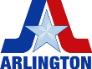
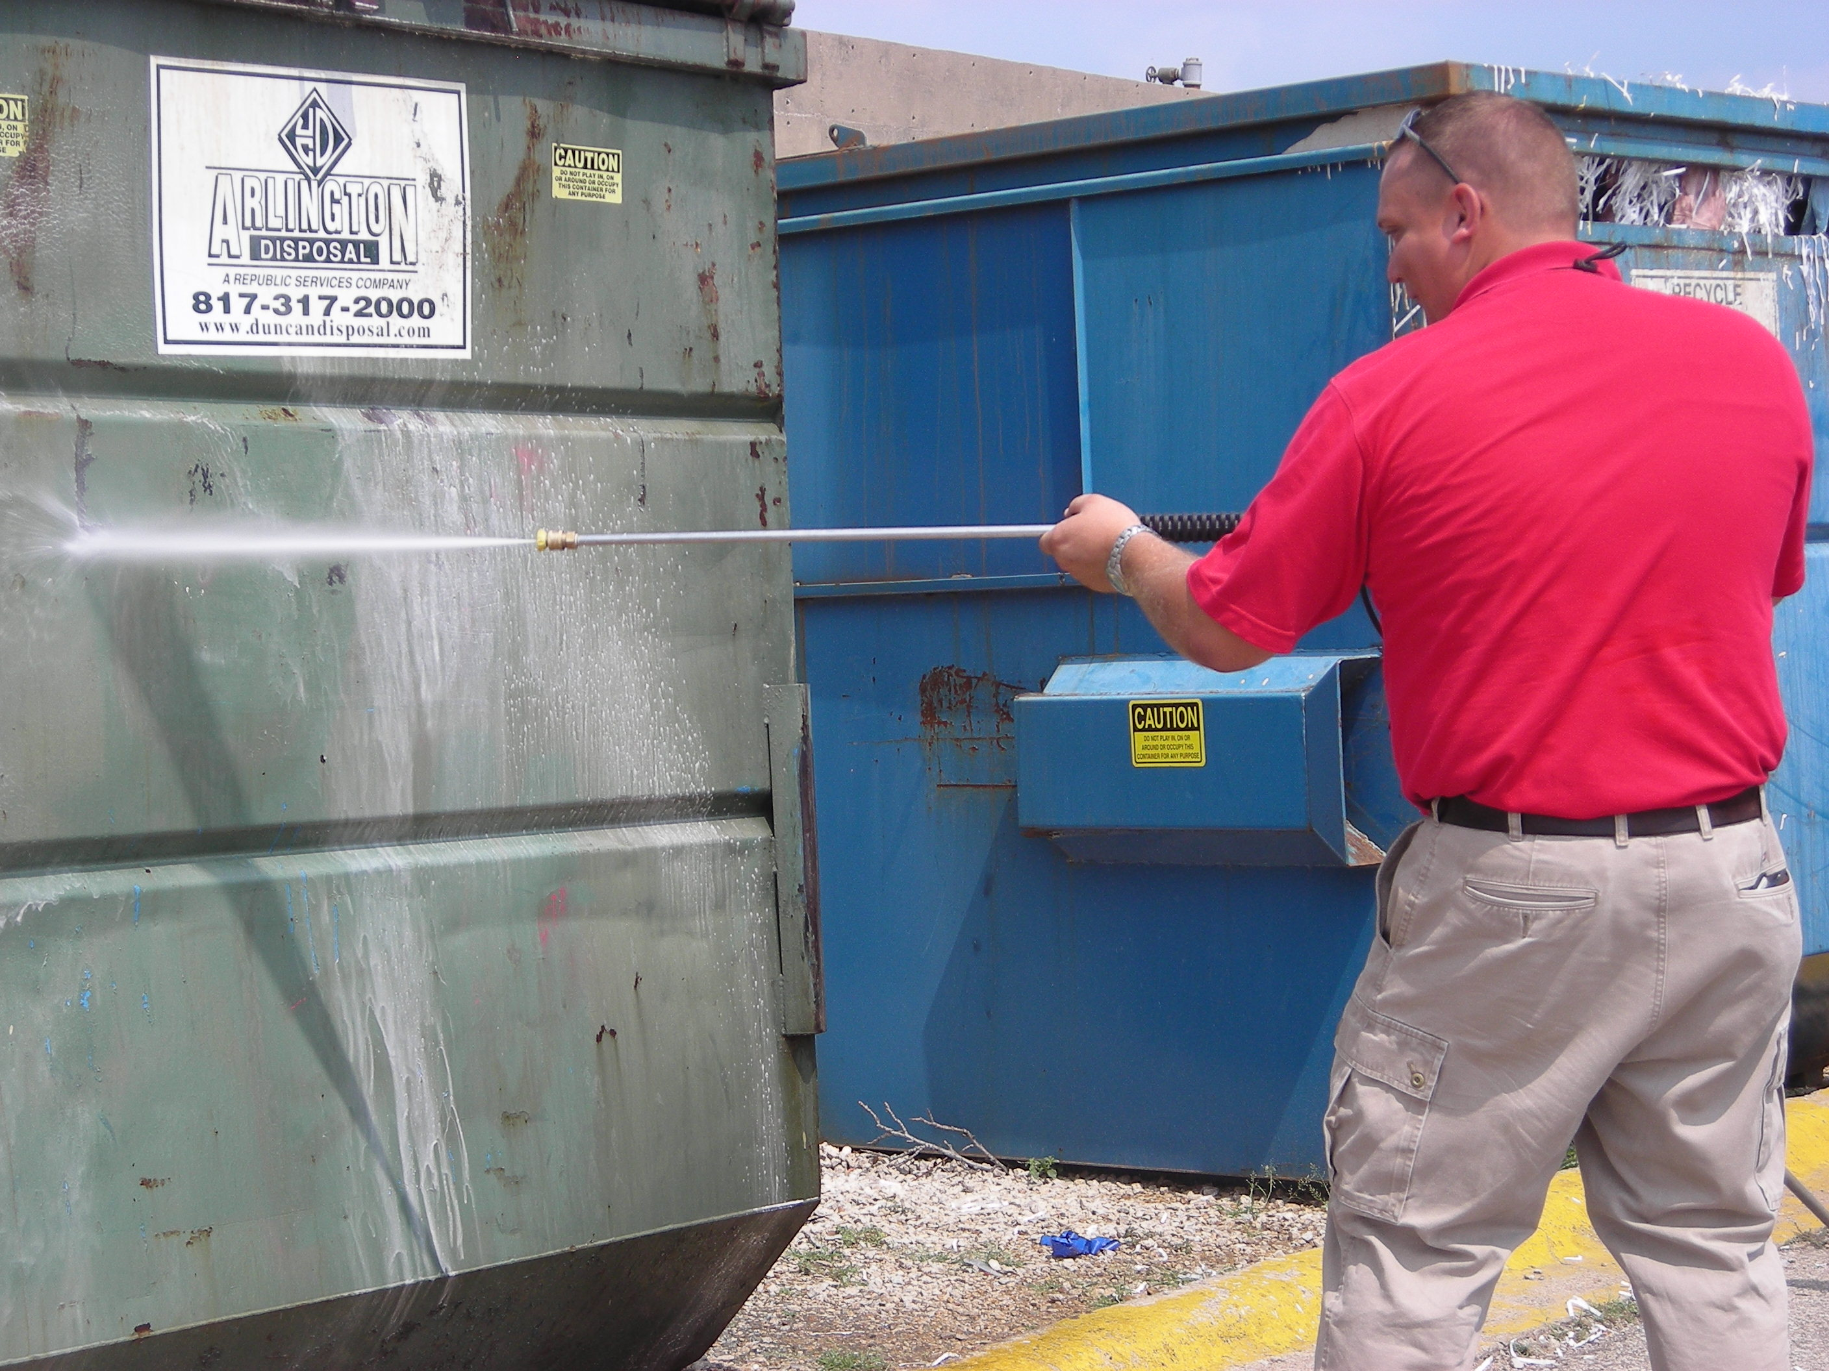
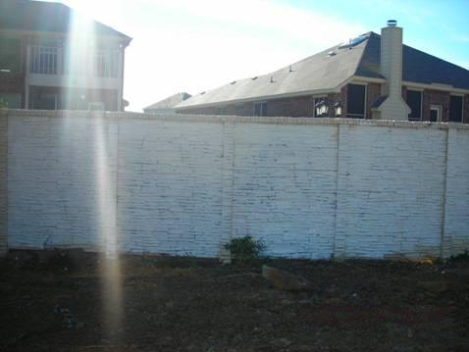
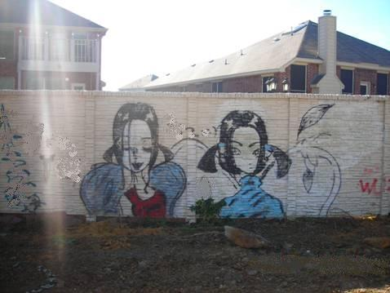
After

Before

City of Arlington, Texas

Submission by the
Community Services Department
for the

2008 ICMA Program Excellence Award

Nominee Program: | Graffiti Abatement Team (GAT)
Nomination Category: | Community Health and Safety Award
March 2008

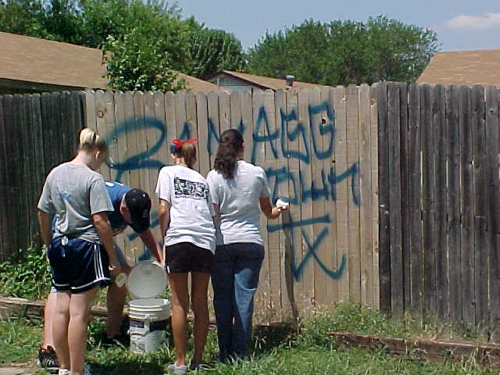
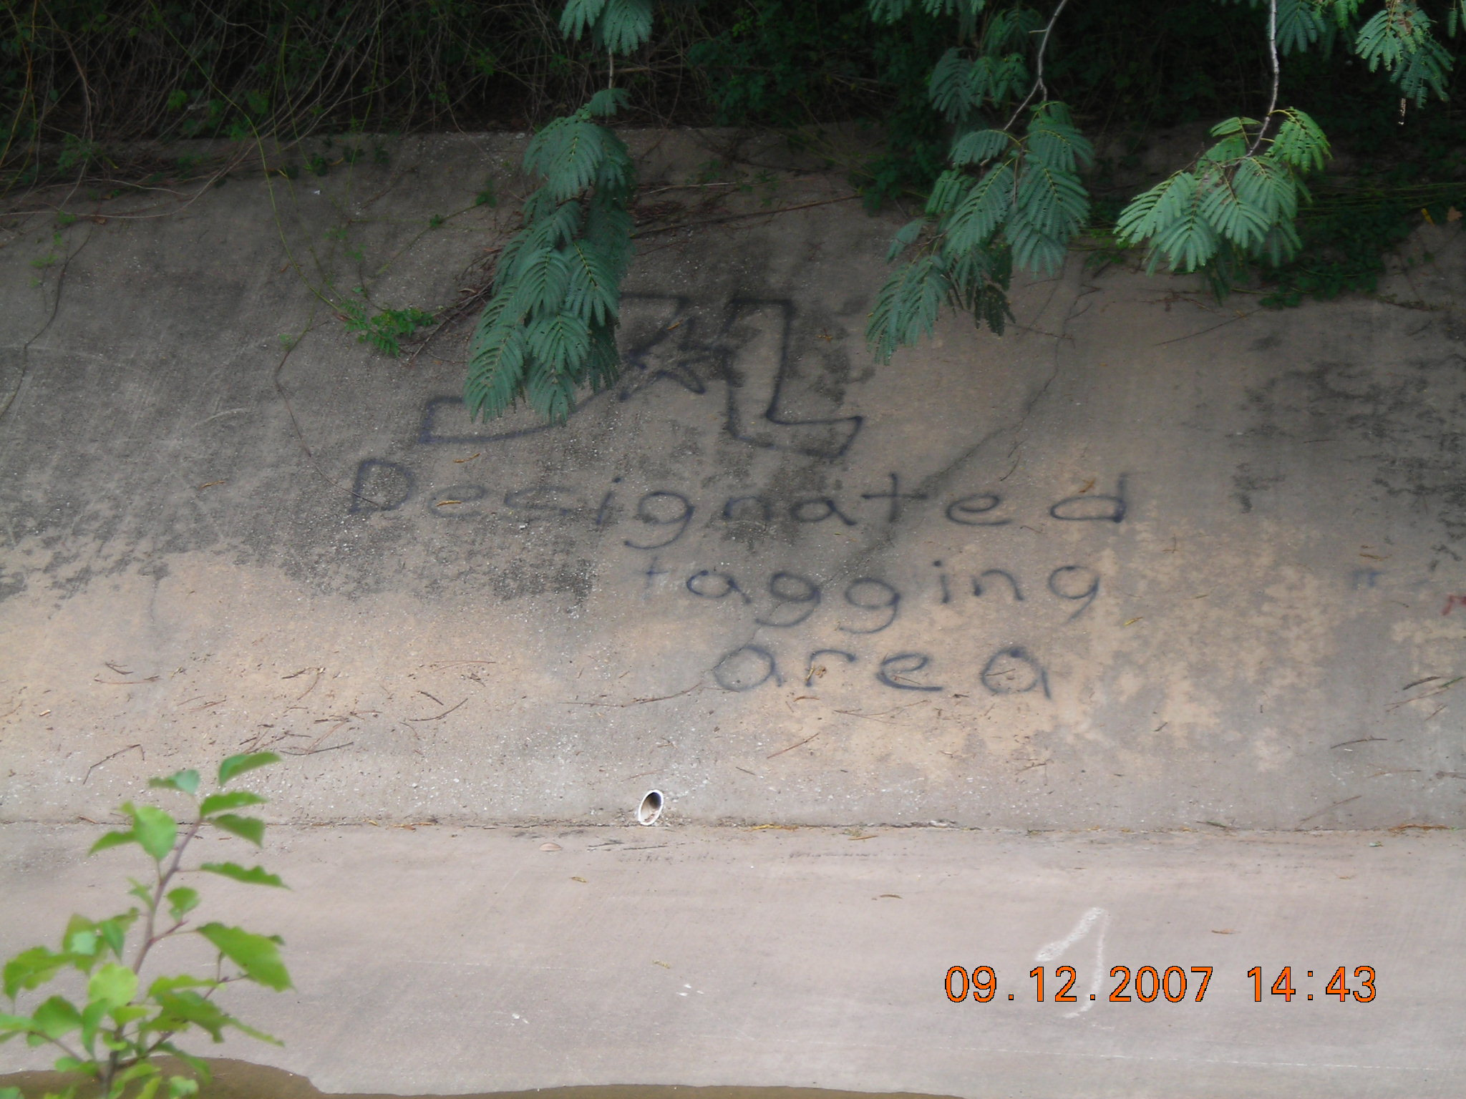
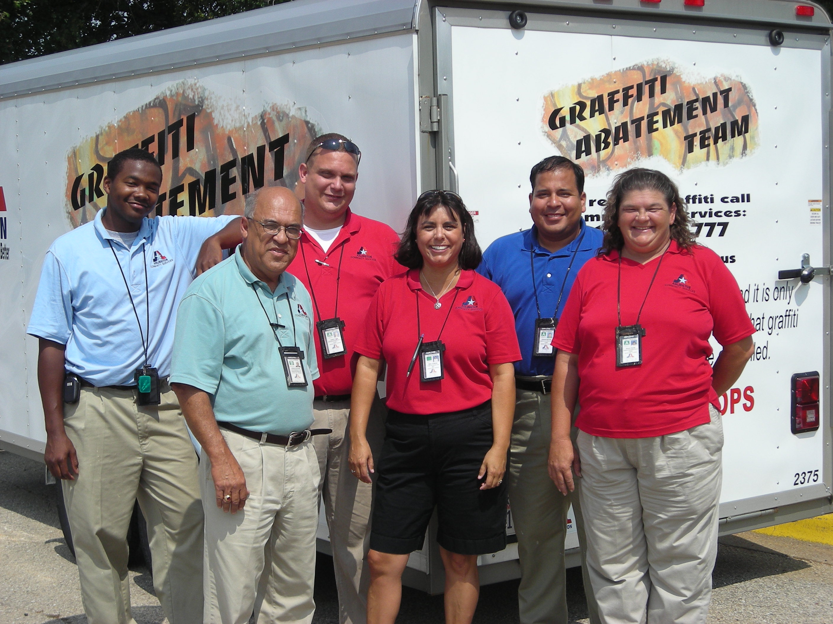

After
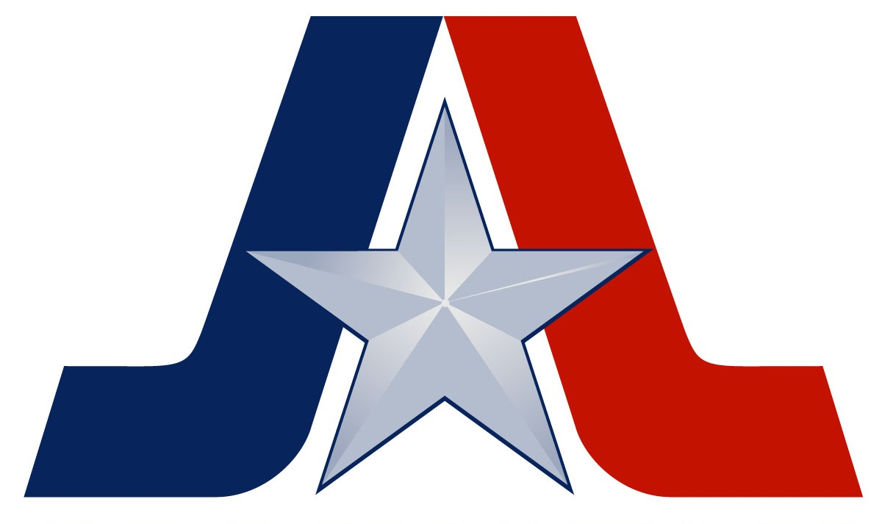
Arlington, Texas is a community of over 360,000 citizens located in the heart of the Dallas/Fort Worth Metroplex. Arlington is the seventh largest city in Texas and the 54th largest in the United States. Home to the Texas Rangers Major League Baseball, Six Flags Over Texas, and future home of the Dallas Cowboys, Arlington is a vacation destination for more than 6 million visitors a year.
The City’s mission is “to enact the will of the people through their active, inclusive participation and to provide the services they demand in a quality, cost effective manner”. In order to achieve this mission, the Arlington City Council sets expected outcomes for city departments. The Community Services Department is a part of the Neighborhood Services city service team, along with the Police Department, Fire Department, Parks and Recreation Department, and Library Services. The priorities set for the Neighborhood Services Department are:
- Increased code enforcement
- Arlington is a city where people feel safe anywhere, all the time
- Neighborhoods are reinvigorated
Everything the Community Services Department does is accomplished with these three outcomes in mind. Additionally, the Community Services Department is guided by a departmental mission, which is directly tied to the mission of the City of Arlington, and City Council’s priorities:
“The mission of the Department of Community Services is to engage, connect, and protect the citizens of the City of Arlington”.
One of the major programs implemented in the past year is the Graffiti Abatement Team Program. The City of Arlington recognized the challenge of graffiti abatement due to numerous city departments responding to citizen’s concerns. In response to the City Council’s strategic priority to increase code enforcement, and in an effort to provide seamless service to the citizens of Arlington that had been victimized by graffiti tagging, the Community Services Code Enforcement staff developed a streamlined, unified response to graffiti abatement. This initiative has positioned the City to respond to graffiti in a proactive, progressive manner.
Before implementation of the Graffiti Abatement Team Program, the responsibility for graffiti removal depended on whether the graffiti was located on public or private property. The table below identifies the parties that were responsible for graffiti removal.
When graffiti occurred in public rights-of-way, the Public Works Department was responsible for removal. Public Works typically responded to the graffiti complaints within 48-hours with equipment and personnel to accomplish limited amounts of graffiti removal. Graffiti incidents that exceeded the capacity of Public Works staff were contracted to a third party service provider.
Location of Graffiti | Responsible Party
COA Public Rights-Of-Way | COA Public Works Department
City Parks & Other City-Owned Properties | COA Parks Department
Private Property | Private Property Owner
TXDOT Rights-Of-Way | TXDOT
Utility Easements & Associated Apparatus | Respective Utility Companies
When graffiti occurred in City parks or on other City-owned property, the Parks and Recreation Department was responsible for graffiti removal and usually responded within 24-hours. Parks staff used a combination of paint, graffiti removal spray, a rented sandblaster, and a private contractor to abate graffiti.
When graffiti occurred on private property, the property owner was held responsible for its removal. Both the Police and Community Services departments were responsible to proactively and reactively enforce the City ordinance, although only the Police Department could issue citations for graffiti violations.
Action by the City Council created the opportunity to consolidate graffiti abatement resources. City Council approved a budget of $64,000 to hire three part-time Graffiti Abatement Technicians to work city wide, including funding for marketing materials, forms, power washing equipment, one vehicle and trailer. The Graffiti Abatement Program was fully implemented in October 2006. Procedures were authorized by City Council to provide graffiti abatement free of charge if the property owner signed a release and hold harmless waiver. The Graffiti Abatement Program was designed to provide a long term partnership and relationship with property owners.
Through the development and implementation of the Graffiti Abatement Program, staff learned quickly of the need for a balance between code enforcement, community education and compassion in the implementation of the program. From the resident’s perspective, being held accountable to abate graffiti after they were the victims of this property defacement was perceived as the City ‘adding insult to injury’. Unwelcome graffiti generally creates a fear response in a neighborhood. Residents typically feel violated and less safe in their neighborhood. With the concerns of law abiding citizens in mind, Community Services staff welcomed input from community stakeholders, citizen groups, Police, Parks, Recreation and Public Works Department staff and created responsible, responsive operating guidelines.
The City learned that rapid response and removal of graffiti creates a benefit to the community by calming neighborhood fears and restoring the presence of appropriate neighborhood control in the community.
The success of the Graffiti Abatement Program has been well received with many positive results. This program plays an important role in the livability of neighborhoods and the economic vitality of the community. Through a coordinated education effort and response by the City of Arlington’s Community Services Graffiti Abatement Team, the City has experienced a significant increase in reported graffiti complaints and a commensurate increase in graffiti abatement. As of March 14, 2008, 1,305 graffiti complaints have been received, with 63 percent of those being abated by the City.
Graffiti removal response time has also increased significantly. Since January 1, 2007, 99.06 % of the graffiti complaints have been responded to by Community Services staff within 48-hours of receipt of the complaint. In comparison, during the same time frame in 2005-2006, the City’s graffiti response time ranged from three to ten working days.
The graffiti waiver process is vital to the program and provides property owners the opportunity to proactively partner with the City, allowing graffiti removal from their premise before a violation occurs and at no charge to them. As of March 14, 2008, 645 citizens have taken advantage of this opportunity and completed a graffiti waiver. These waivers are maintained on the City’s electronic records, and stay in effect until revoked in writing by the owner of record.
In addition to rapidly increasing graffiti abatement response time, the Graffiti Abatement Program has resulted in building good will. Citizen feedback regarding the Graffiti Abatement
Team initiative is extremely positive. The following are quotes from Arlington citizens.
“Thank you so much for getting this taken care of. We are working hard on our neighborhood and your support is greatly appreciated.” Julia Moore
“Great job. Looks so much better.” Bonnie
“I’m surprised that a city would help for free. I’m so glad to live in Arlington.” Ms. Blackburn
“Thank you and thanks to GAT for getting the graffiti at 2000 Busch taken care of. You are the greatest thing to happen to the city of Arlington.” Gil and Bonnie Ginn
On a systemic level, decreases are apparent in the number of gang-related offenses in the city, and more specifically, graffiti-related offenses. The following two charts show data provided by the Arlington Police Department.

The Graffiti Abatement Program serves as a cost-effective example of how a bold paradigm shift in delivering municipal services can improve the livability of a city through collaboration, private-public partnerships and out-of-the box, creative thinking. Through the Graffiti Abatement Program, the City of Arlington and the citizens of our city are truly “working together to make Arlington better”.

