Annual Cemetery Walk
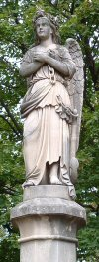
On the 4th Sunday of September each year, the Elgin Area Historical Society hosts the Cemetery Walk at Bluff City Cemetery in Elgin. This beautiful and historic cemetery is the final resting place of many prominent Elginites and has many fine examples of elaborate headstones and mausoleums. Noteworthy citizens are portrayed at their gravesites by members of the Society and other volunteer performers, in authentic historical costumes and in character. The life and times of people buried in the cemetery is presented through a living window to the past in a touching and memorable way—in their own words.

The 2004 Walk
We invite you to join us for the 17th annual Walk on Sept. 26 from noon to 5 PM (last tour leaves at 3:30). This year's walk features those who have been on city staff or directly involved in city government, because this is Elgin's 150th year as a city. The cemetery is located on Bluff City Boulevard, approximately 1/2 mile east of the intersection with Liberty Street (Rt. 25). Bluff City Boulevard is located one block south of U.S. 20 on Elgin's east side. There is a small admission charge.
Here's a brief introduction to the people featured on this year's Walk.
- Dr. Joseph Tefft, physician and Elgin's first mayor, will greet visitors as they begin the Walk.
- Joseph G. Huber was Chief of Police from 1931—1953.
- Nancy Currier Kimball was one of Elgin's earliest settlers. Two of her sons, Samuel and William, served as Mayors of Elgin.
- Louise Schrader and her husband Louis operated a saloon in the late 1800s. Louis was also an alderman for 8 terms, and he had a vested interest in the regulation of liquor.
- David Sharp served as fire marshal in the early 1900s.
- Edwin F. Reeves, a local craftsman, was elected mayor in 1878. As visitors will learn, he had unique views on the prohibition of alcohol.
- Nellie Stiles investigated the city jail in 1907 and declared its conditions "a disgrace to the people of Elgin." Nellie was an active worker in religious and temperance circles.

Scenes from Previous Walks
Here are some scenes from previous years. If you are interested in history, cemeteries, Elgin, or just want to spend the afternoon in a peaceful and beautiful cemetery, come to the Cemetery Walk!
View of Bluff City Cemetery  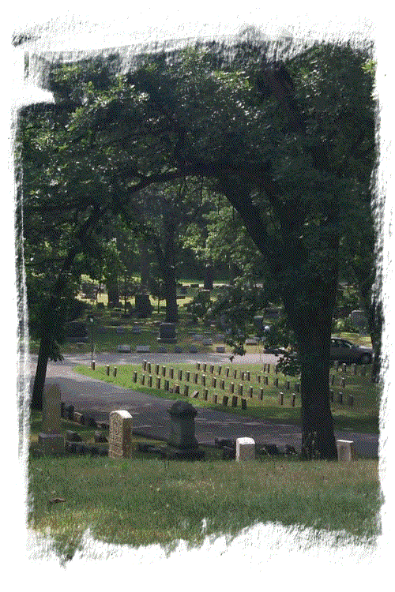 | Tour guides walk visitors through the cemetery, pointing out interesting headstones and providing general information about Elgin and the cemetery. The walk lasts approximately 2 hours.  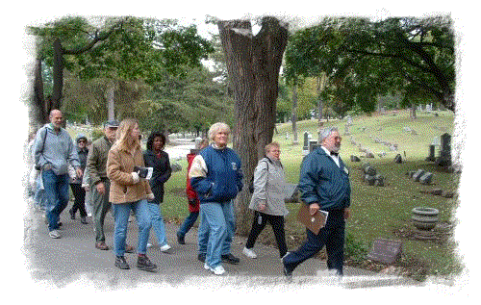
The people portrayed are very interesting.....  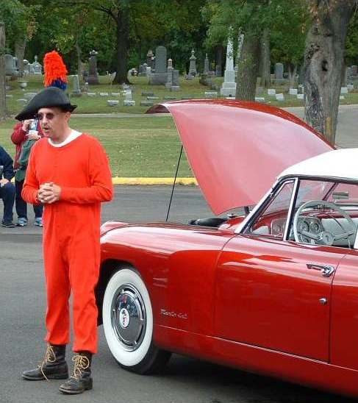 | ........and you will see many fine mausoleums and beautifully carved headstones as you walk.  