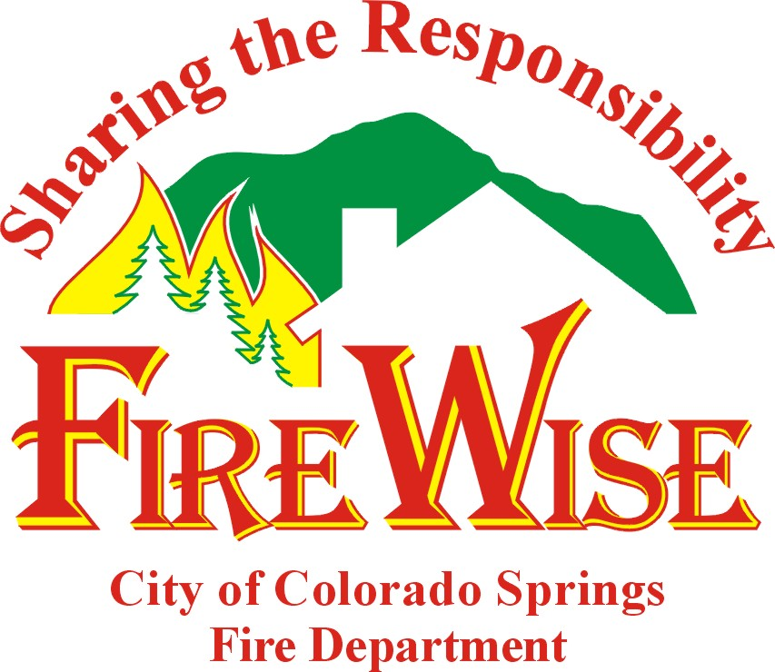

The program mission is to increase community awareness of the wildfire danger
in the city's wildland-urban interface and positively influence community attitudes and behaviors. The Wildland Risk Management Office effectively delivers information to homeowners that assists in reducing their risk and engages the public in taking an active role in creating a safer wildland environment by Sharing the Responsibility.

- Public process and core advisory group initiated in February 2000 provided stakeholders an opportunity to interact and express concerns about the wildfire risk in the city's wildland-urban interface.

- During 2000, Colorado Springs Fire Department staff visited 44,329 individual parcels and conducted wildfire hazard risk evaluations on homes identified in the city's area of study.

- Following receipt of a 2001 grant from FEMA/U.S. Fire Administration the Colorado Springs Wildland Risk Management Office was able to move forward with program development.

- Program design includes a risk management strategy with program features that include a customized FireWise message that is adapted specifically to the local topography, fuels, homes, zoning codes and ordinances, GIS, a Vegetation Management Program, Development Review and Code Enforcement.

- Wildfire Mitigation Plan presented to City Council and accepted March 11, 2002.
http://csfd.springsgov.com/mitigationplan.htm

- Mandatory Evacuation Ordinance passed by City Council March 26, 2002.

- May 2002 - Using an adult education model, communication was initiated with interface homeowners to create awareness that they live in a high-hazard wildland fire environment and deliver information that will reduce their risk. Residents that develop defensible space, perform vegetation management and "harden" their structure are reducing wildfire hazards.

- FireWise interactive web site (http://csfd.springsgov.com) released to the public June 12, 2002. The site contains ratings for 44,329 parcels within the city's interface. Homeowners now have access to their individual wildfire risk parcel rating (Extreme Risk, Very High Risk, High Risk, Moderate Risk and Lower Risk) and are encouraged to also view their overall neighborhood ratings. An easy-to-use map with the capability to locate a specific address or entire neighborhood makes the search simple. Vegetation management techniques are available on the site and when the suggested work is completed the FireWise office can be contacted to schedule a new evaluation. This site serves as a de facto statement of the community's acceptable risk.

- More than 10,000 residents have visited the site since June 12, 2002. A significant percentage of these individuals have engaged in doing the suggested work. Residential participants in the FireWise program have exceeded our expectations.

- Since May 2002, the FireWise Colorado Springs Program Coordinator has presented to more than eight hundred individual homeowners through neighborhood/homeowner association groups, civic organizations and public venues.

- Citywide Class A Roofing Ordinance effective January 3, 2002. All new roofs or repairs greater than 25% of the total roof area will be required to use Class A roofing materials. Under the ordinance, all types of solid wood roofing products will be prohibited in this use.

For more information, contact Brett Lacey, Fire Marshall at (719) 385-7355.

