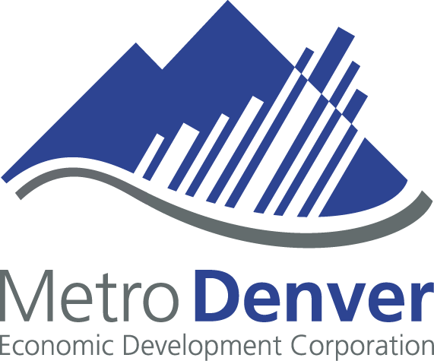

Economic Development 101
Economic development is a vital activity for any community. It is the process of creating greater wealth within a community by bringing in new "outside" dollars. This is mainly achieved through:
- Retention, expansion and recruitment of "primary" jobs
- New capital investment
- Attracting visitors to spend money in the community
What is a "primary" job?
A "primary" job is a job that produces goods and/or services for customers that are predominantly outside the community. This creates new "outside" dollars for the community. Once an employer is paid for the products and/or services, he redistributes that wealth in the community through wages paid to employees and through suppliers.

Why does our community need "greater" wealth?
Economic development programs vary based on the needs of a community. There are several benefits of a successful economic development program.
1. Higher quality public services–By increasing the tax base of a community, local governments can provide higher quality public services to citizens. This could mean additional police officers to help ensure public safety, additional parks and recreation areas, etc.

2. More job opportunities for citizens–Adding "primary" job opportunities to a community gives citizens more opportunities to find higher-paying jobs closer to home. "Primary" jobs usually pay a higher average wage than the average per capita income of the community. They also create additional or "spin-off" jobs within a community.
3. Greater protection from economic downturns–One of the focuses of economic development is to diversify the economic base, thereby increasingly cushioning the community against economic shocks. A community that has not diversified its industry base can find itself in trouble if its single, major industry downsizes or suddenly leaves the community.
What does an economic developer specifically do?
Economic developers wear many different hats. However, there are three main functions an economic developer performs:
I. Provide information and assistance to companies that are interested in the economic developers community for relocation, retention or expansion
Economic developers do not create new jobs. They provide information and assistance to companies who create new jobs. A good economic development program strives to have the most comprehensive and current information available on the following:
- Local demographics
- Public infrastructure and costs
- Real estate
- Taxes, fees, and regulations
- Quality of life
- Business assistance programs
2. Market the community to targeted business industries
Like any company, if a consumer isn’t familiar with your product, they won’t buy it. Another function of an economic developer’s job is to market the community to businesses in "targeted" or specific industries best suited for the community. Marketing activities often include:
- Print advertising
- Recruitment trips to targeted areas
- Tradeshows
- Multi-media presentations
- Cold calling
- Site selection conferences
- Public relations
3. Work with elected officials and community partners to ensure that a positive business environment exists in the community.
The same things that attract new employers will keep existing firms in the community. There are several reasons why companies thrive in certain communities and struggle in others. These factors include:
- Proximity to markets
- Ease of international travel
- Local labor skills and availability
- Tax and regulatory environment
- Quality of life issues
- Cost of doing business
- Strong and stable political leadership
- Incentives
- Infrastructure
- Proximity to major universities
- Concentration of existing industries
Economic developers work with elected officials and community partners to strengthen any gaps in the community related to the above items and make the community more desirable for businesses.

For more information please contact the MDEDC:

Metro Denver Economic Development Corporation (MDEDC)
1445 Market Street
Denver, CO 80202
Phone: 303.620.8092
Fax: 303.534.3200
www.metrodenveredc.org
info@metrodenveredc.org

