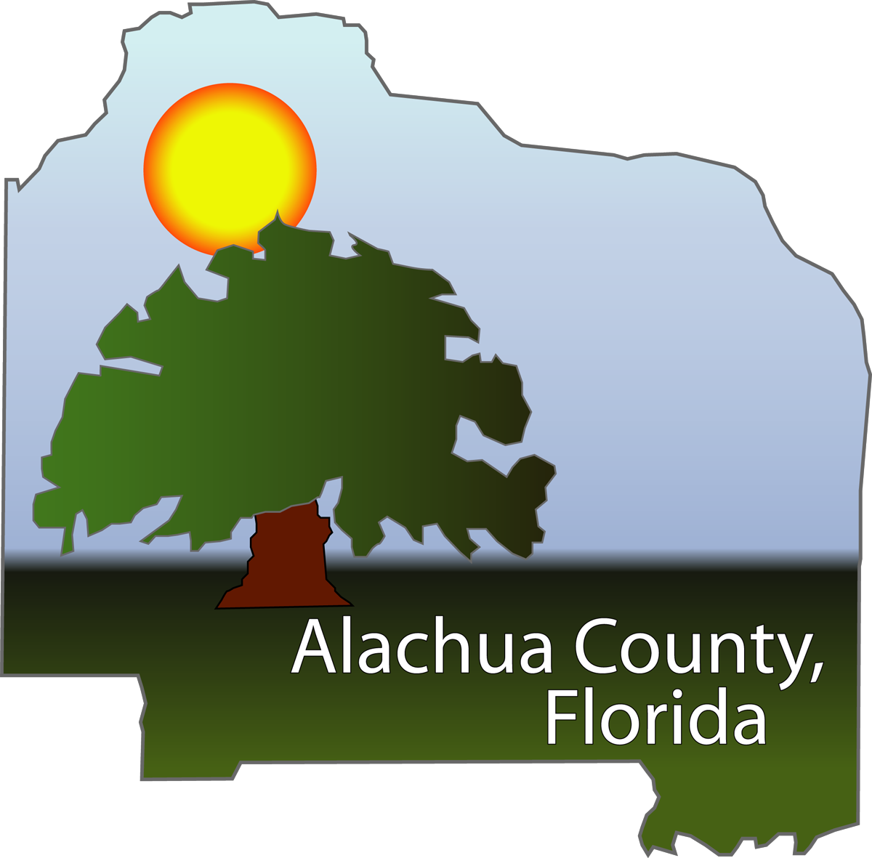

Havlick and Muehlenbeck Award Nomination

Name: Donna Bradbrook
Title: Strategic Performance Manager
Jurisdiction: Alachua County Board of County Commissioners

Mailing Address: 105 SE 1st Avenue
Suite 6
Gainesville, FL 32601
Phone: 352-264-7066
Fax 352-338-7362
E-mail: dbradbrook@alachuacounty.us

Alachua County’s Cultural Assessment and
Sustainable Workplace Action Plan

According to Maslow; “Self Actualization is the intrinsic growth of what is already in the organism, or more accurately, of what the organism is." Beginning in Fiscal Year 2007 Alachua County embarked upon a journey of self actualization by conducting an Organizational Culture Assessment to gain a better understanding of our organizational culture and to address change through idea sharing, research, innovation, and organization-wide participation. The journey began with the Sustainable Workplace Action Team and developed into the Sustainable Workplace Action Plan, which is a multi-year continuous improvement program that will enhance our ability to achieve results through program development, policy review, strategic planning, and employee focus.

Alachua County:
Alachua County was incorporated in 1824 and encompasses 977 square miles with a population of approximately 240,000. The Alachua County Board of County Commissioners has 800+ employees that provide services in such diverse areas as Community Services, Fire and Rescue, Public Works, Environmental Protection, Growth Management, and Court Services. Our collegial community, including both the University of Florida and Santa Fe Community College, blends very nicely with our unique natural surroundings and features such as Payne’s Prairie State Park and numerous natural springs, lakes, and preservation areas.

History:
Alachua County’s leadership ethic is “creating respect for people and place”. As we entered FY 2007 we were faced with some tough challenges, including reduced sales tax revenues, a state legislature intent upon limiting a municipal jurisdiction’s ability to collect taxes while eroding the Home Rule, and a declining housing market. We needed to examine our own organizational work place and how we could sustain a quality working environment during an era of limited resources. With all of this in mind, the Commissioners whole-heartedly endorsed utilizing Innes Strategy in partnership with Alliance for Innovation to administer, consult, and report on the Organizational Cultural Assessment survey. To continue the work initiated by Greg Innes, the Sustainable Workplace Action Team (SWAT) was formed.

SWAT was tasked with:
- overseeing the administration of the survey,
- helping communicate the purpose, intent, and progress of the program,
- being champions to ensure momentum on the Action Plan items,
- ensuring front line participation, input, and impact,
- developing tools to ensure the success of the program,
- aligning Action Plan items with functional groups,
- tracking and reporting on progress of the Action Plan,
- acting as custodian of the program.

The SWAT worked closely with Managers and Supervisors to evaluate the survey results and to develop a Sustainable Workplace Action Plan. And the SWAT will continue to work with front-line employees through focus groups, action teams, and informal committees to continue to develop the Action Plan and implement the Action Plan items.
Importance, Impact, and Benefits:
The importance of the Cultural Assessment survey and the Sustainable Workplace Action Plan (SWAP) include continuing the sustainable cultural change process, enhancing organizational effectiveness, and increasing employee satisfaction. The immediate impact and benefit is a better understanding of the organizational culture. The impact resulting from the evaluation of the survey results was the development of an Action Plan that we will use as a guide for items to focus on in the immediate future, short term, and long term.

Some of the Action Plan items identified include:
- Increase employee recognition
- Encourage self assessment and development
- Create partnership directory
- Collaborate with elected officials and municipalities
- Improve interdepartmental coordination and cooperation
- Implement users groups of front line users and customers to champion improvement
- Solicit and implement employee suggestions for process improvement and cost reduction
- Develop and use web-based collaborative tools
- Empower front line employees
- Increase public awareness of County departments

The short and long term impact and benefits have not been fully recognized yet, however, we understand that we are embarking on a multi-year process.

Who Benefited:
Having meaningful focus in our work and ultimately our lives takes place only in a workplace filled with people and relationships, systems, vision, and policies that promote interaction and participation. The Organizational Cultural Assessment tool allowed each employee to examine our organization from their very important and unique perspectives. This process was the best opportunity to actually try to define the organizational culture in our very large and complex organization and examine how to improve it over upcoming months and years. Each employee was given a tool to voice how we collectively “experience” our working environment now and how we hope to experience it in the future.

Employees actively participated and with a 74% survey participation rate, we heard their voices. With the survey results and on-going analysis of the data, we can determine where we can concentrate our resources to provide a better working “experience” for our future work life in Alachua County.

With more satisfied employees, we are able to better serve our citizens, businesses, and customers, we are better able to interact with our action committees, special interest groups, and commissioners, and we are better able to sustain our way of life.

Innovation Initiated and Implemented:
Through the use of a web-based survey tool and multi-tiered reporting capabilities, we are able to graphically map and evaluate nine components of organizational culture such as communication, change tolerance, internal organization and control. We initiated this process by utilizing the diversity of the Sustainable Workplace Action Team to champion the cause and we continue to implement the Action Plan items. We used e-mail, presentations, focus groups, informal department communications, dedicated intranet site, and newsletters to communicate the survey results and Team activities.
Risks:
Undertaking such a wide ranging program can pose many risks. While planning for and implementing the survey and resulting action plan, we were acutely aware of possible risks such as low employee survey participation, employee’s not taking ownership of the program, and employee survey responses skewed due to fears of budget cuts and economic hardship.

Even with all of the possible risks, we still decided to take on this challenge because it was the right thing to do. We mitigated the possible risks by ensuring open and honest communication with regard to the survey and what we planned on doing with the survey results.

Environment:
As was mentioned above, Alachua County was facing and continues to face fiscal uncertainty including reduced sales tax revenues, reduced property tax revenues, and the erosion of Home Rule. The environmental factors made it even more important to capitalize on our employee resources to develop an environment of sustainability through a shift in organizational culture. According to the Cultural Assessment survey results, the environment we work in is perceived by our employees to be administrative and comprised of routine processes; our employees want to function in an environment that is integrative, teamwork based and innovative.

Execution Costs and Savings:
Administration of the survey tool and on-going consultation fees during the survey process totaled $85,000. The current cost savings are intrinsic, however, as we continue to implement Action Plan items, we will gain employee commitment and engagement, customer satisfaction, and process improvement.

Lessons Learned:
We learned through this process many lessons. Among those that stand out, 1) Communication at all levels and in multiple formats is imperative for an agency wide initiative, 2) Having strong team members that are passionate about what they do will make things go more smoothly, 3) Being organized in your process and thinking through each step for those ‘what-if’s’ will help to avoid unforeseen pitfalls.

Communication:
When dealing with communication, being open, honest, and forthright was imperative. We learned early on that when there was a void of information, problems would result.

We started with communications focused at the Leadership level and cascaded those communications all the way to the front-line by using e-mails, department meetings, focus groups and workshops. Focus groups were held with approximately 14% of our workforce to listen to what their concerns were and to wrap their concerns into the survey questionnaire. Those focus group employees were able to help shape the survey tool and therefore took ownership of the importance of the survey.

When the survey results were available, we offered workshops for any and all employees to attend. We even took the survey results on the road by delivering a workshop at our off-site Public Works department were work crews have a difficult time breaking away from their daily work to travel to the downtown for a meeting. The dynamic survey results reporting tool was uploaded by our Information & Telecommunications Services department to our shared access web site so that any manager, supervisor, or employee could look at the composite survey results. Individual employee answers are not available at any level to protect the confidentiality of the survey responses. Communicating a) what we were doing, b) what we were going to do with the results, and most importantly c) the changes that were implemented and continue to be implemented as a result of the survey and Action Plan is important to highlight that we not only talk the talk, but walk the talk.

Team Members:
We have embarked upon other initiatives that have started strong and then fizzled due to other priorities or projects or lack of direction. Having a strong team to lead this program that was passionate about the mission was critical to its success. Team members that were willing to work on weekends, go outside of their comfort zone, attend four and sometimes five multi-hour meetings per week, speak in-front of large crowds of employees, managers, and leadership, and champion a program that was not necessarily supported by all staff is a tough burden to handle. Selecting members that were subject matter experts who were willing to champion a cause, who weren’t afraid of challenge, and who were willing to spend personal time and effort to ensure the success of this program was the real challenge. Once we had those members together, the team became an entity of its own, seemingly taking a concept from paper to reality, of course with help from the consultant. Now that the consulting agreement has ended, the Action Plan items that remain are being assigned to functional groups and employee teams to spearhead. The ownership of these longer term Action Plan items will be shared among many teams with the SWAT team being the champion and maintaining an oversight and reporting function going into the future.

Organization:
Administering an on-line survey to 800+ employees who in some cases do not have access to computers can be challenging. Reaching out to all employees with survey results, Action Plan items, and on-going reporting of the SWAT activities can also pose challenges. We learned that it was a must to have well organized staff to support the SWAT team with challenges such as:
- locating and hooking-up dozens of PCs at remote sites so those without regular access to PCs could take the survey
- coordinating meeting room space to hold upwards of 150 employees at a time
- arranging for coverage when a majority of managers and supervisors were attending focus group meetings to develop an Action Plan
- coordinating the massive amount of information that came from focus groups, workshops, training, meetings, and sub-team activities
Without the organizational skills of many, this program would not have been as successful as it has been.

Champions of Innovation:
The true champions of this process were those employees at all levels of the organization who took on the added role of being a Sustainable Workplace Action Team member and who believe that by embracing this process and making the most of very action that they would be able to improve the outcomes for all of our stakeholders. In addition to their regular duties, they became Team chairs, sub-team chairs, team members, communicators, participants, and advocates. Without those dedicated individuals, this process would not have been realized.

Conclusion:
Through the Cultural Assessment survey tool, the continued actions of the Sustainable Workplace Action Team, and the on-going refinement and implementation of the Sustainable Workplace Action Plan, Alachua County will continue on its journey of intrinsic growth to support sustainability.

