2009 Transforming Local Government Conference
Imagining Innovation
May 13 - 15, 2009 ~ Corpus Christi, TX

Case Study Submittal For

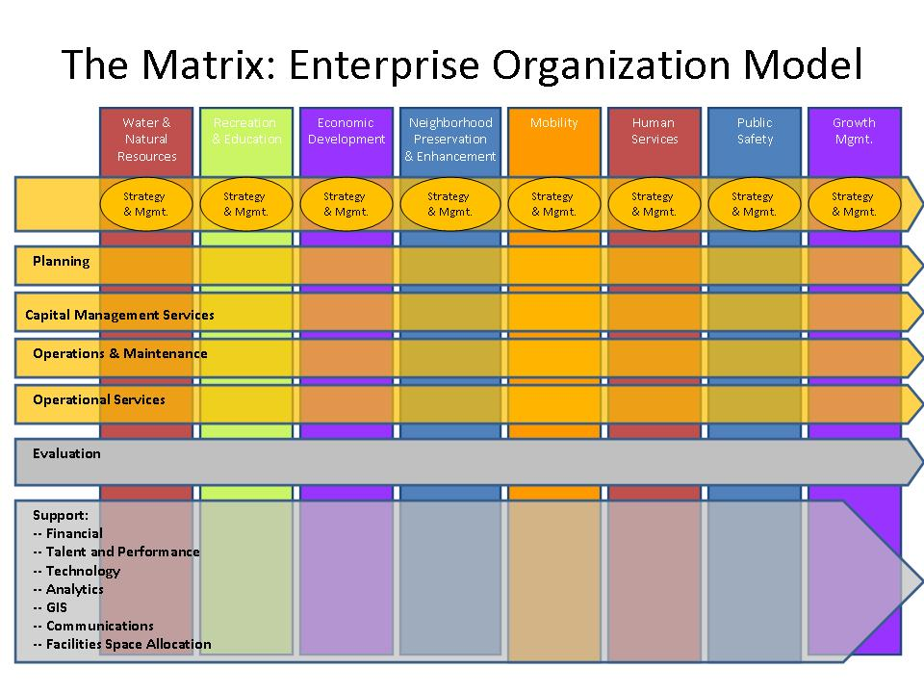

Sarasota County Presentation Team Members

James Ley
County Administrator
1660 Ringling Blvd.
Sarasota, FL 34236
Tel: 941.861.5111
Fax: 941.861.5987
jley@SCGOV.net
Mary Sassi Furtado
Executive Director of Strategic Operations
1660 Ringling Blvd.
Sarasota, FL 34236
Tel: 941.232.6516
Fax: 941.861.5960
msassi@SCGOV.net

Sarasota County Government regularly assesses the business models (organization structure, products, processes, and results) for each of its service areas against best practice models and research from industry and public sector. In recent years these assessments have resulted in projects that enabled Sarasota County to achieve significant gains in the efficiency and effectiveness in a number of support service areas. Once identified, the implementation of these business models yielded improvements in the efficiency and effectiveness of each service.
Being clear about our public service goals, and our role in delivering community outcomes, is paramount. Our current County Administrator established the following four goals in 1998. They remain strong and valid today.

- To build credibility with the public by creating a customer focused organization that is accountable for its actions and responsive to the needs of citizens.

- To modernize the organization in pursuit of one that is smaller, higher performing, and fairly paid.

- To create a motivated staff that is responsible and accountable, having been provided with the tools to leverage opportunities for improved workflow in a simplified organization.

- To build upon a foundation of technology for increasing productivity and enhancing efficiency in our work practices.

This practice continues at present, in part due to increasing fiscal and economic pressures facing all sectors of our economy, and the latest service areas to undergo this examination include those with considerable interaction with and touch-points to the community - Public Works, Utilities, and Parks & Recreation. The current assessment of these business models has resulted in a decision to implement a matrix management structure. The matrix model embeds a disciplined and consistent approach to accomplishing work in a structure that is flexible, adaptive, and responsive to community needs, resulting in enhanced operational excellence overall. In looking at the SCGOV Matrix graphic, the vertical columns represent key community outcomes (the “what” we do), while the horizontal rows depict core functions or business processes around which staff organize in order to deliver those key outcomes (the “how” we do it).

Four of the five horizontal functions depicted in the SCGOV matrix represent key interdependent, enterprise-wide business processes: Planning, Capital Management, Operations & Maintenance, and Evaluation. In fact, it is no accident that these four functions, when linked together, embody the cradle-to-grave total asset life cycle. The Operational Services function represents those service areas without tangible physical infrastructure assets that need to be planned, constructed, maintained, and operated. Most operational services involve significant community interaction and are service-based. (Examples include the delivery of library services, health services, and fire/paramedic services.)

Our key focus to date has been on Capital Management Services (CMS), and Operations & Maintenance (O&M) – primarily because of the magnitude of the infrastructure investment and labor costs associated with each. Our five-year capital improvement program includes nearly $1 billion in public infrastructure projects. Approximately 375 employees, all with a primary focus of delivering maintenance services and maintaining physical assets, are part of the consolidated O&M function.

The principle purposes embedded in each of the horizontal disciplines are exactly the same:

- define, refine and implement consistent work processes derived from best business practices;
- coordinate and balance functional service delivery across multiple knowledge disciplines to drive outcomes;
- exercise objectivity in establishing functional priorities from amongst the many competing demands for organizational resources, and
- adopt a community rather than a departmental approach to accomplishing work.

The matrix approach allows for the integration of our functional processes (or “micro-businesses”) across artificial departmental boundaries. Put plainly, the SCGOV matrix attempts to end the bureaucratic, department-driven approach to serving community; we are challenging the validity of “the color of money” as a limiting factor to exercising common sense in accomplishing our work. No longer will there be…

- …four different departments performing the function of managing capital construction, each for a single outcome area like transportation, stormwater, facilities, or parks; there will be one department that constructs projects in pursuit of those various outcomes.
- …four or five different departments in which employees hold responsibility for mowing grass – on street medians, around county facilities, in public parks, or around stormwater ponds; there will be one department that mows grass in all of these areas, as the skills required do not vary from location to location.

There does exist some constancy amidst all of the change. Some things will remain largely as they are today. Our simple mission of government – improving people’s lives – doesn’t change. The four goals established by our County Administrator in 1998 don’t change. The community outcomes don’t change. Certain families of services (most classified in the Operational Services row of the graphic) are not changing. There are either no or minor changes in Community Health & Human Services, Community Information & Education, Environmental Resource Management, Planning & Community Development, and Public Safety.

In terms of governance principles, the SCGOV matrix hinges upon clarity of role, specificity of performance expectations, and constancy and honesty of communication. The entire leadership team shares responsibility for accomplishing the stated desired outcomes (the verticals), with point people assigned to each outcome based on specific subject-matter expertise. In order for the outcome owners to accomplish their work, they must define and negotiate service-level agreements with the functional owners (the horizontals). To illustrate using analogy, the vertical outcome owners act as account representatives on behalf of the outcome, convening and marshalling organizational support resources such as CMS and O&M in much the same way that they would obtain traditional support services like information technology, human resource management, and fiscal support.

SCGOV’s move to the matrix challenges the underpinnings of our existing compensation and classification structure. Successful matrix management requires broad empowerment of individuals at all levels of the organization. This requirement has catalyzed an initiative to significantly flatten the organizational hierarchy (with a goal having been set of not surpassing five levels of supervision from County Administrator to field worker), increasing individual span of control at all levels. Recognition of the drivers that created the existing hierarchy has caused us to differentiate managerial tracks from technical, professional, paraprofessional, and skilled trade tracks for career growth and compensation. The objective is to move past a compensation system where the only way to recognize the skills and contributions of a high-level professional or technical expert is to promote that person into a managerial role, a practice that has proven unsustainable in terms of controlling overhead expense and increasing operational efficiency. These career paths are codified through broad-banded job classifications with wide salary ranges and incrementally-increasing skill levels.

To an individual employee, the matrix model creates new and varied career opportunities. Employees have at their disposal the ability to progress through a particular career path of their choice or to make lateral career moves into new areas of expertise. In our future organization, “Up is not the only way!” In either case, the competencies and skills required for advancement are laid out clearly and transparently, so the career path is visible. Additional benefits exist in the opportunity for cross-training and diversification of skills within a job.

So, when all is said and done, what benefits will Sarasota County derive from the move to matrix management?

Community Benefits:

- seamless service delivery from a citizen perspective rather than bureaucratic responses to community issues or problems;
- adaptive and nimble governmental resource allocation to ensure that the top community priorities can be resourced as such;
- acknowledgement of the desire for local government tax reform, manifest in lower tax burdens made possible through the reduction of redundant overhead expense and operational waste

Internal Organizational Benefits:

- a cultural transformation where employees see themselves as “stewards of the whole” within a nimble network of talent rather than as employees of a single department;
- institutional knowledge capture through documentation of work processes and implementation of best practices in work and project management;
- increased efficiency through decreased costs;
- improved effectiveness through increases in productive capacity,
- strengthening of the talent pipeline through provision of new opportunities for skills development and career path exploration for individual employees.

Innovation/Creativity

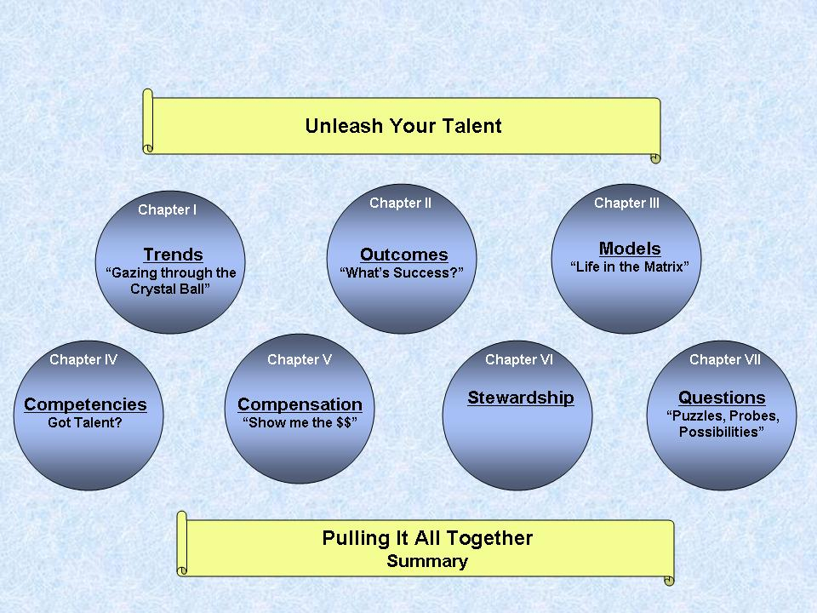
How did you encourage creativity in order to generate solutions?

When the realization that the service delivery model of the recent past would
not withstand the economic pressures
and challenges of the present finally sunk in, employees were granted free license to create
a new model that would serve our citizens well
in a fiscally responsible manner. The
administrator asked all employees to examine
the fundamental assumptions of the status
quo and challenged employees think through
how we could modernize our organization without compromising our key outcomes.
This process was very liberating, as a blank
slate knows no limitations.

The administrator further challenged staff to own their futures, to understand, enhance, and unleash their talent. This approach encouraged individuals to assume ownership of their professional destiny, pushing the impetus for action to the level where it makes the most sense. SCGOV staff developed an “Unleash Your Talent, Maximize Your Potential” program that stimulated employee understanding of the variety of roles they could play a different future.

Employees were prompted to ask themselves, “How solid is the foundation you have designed? Do you clearly understand the business challenges and how your talents might support our future direction? Can your plan adapt to change as needed?” The end result of this was a simplification of career paths and widening of pay bands within our organization.

How did your program/concept stretch or improve the boundaries of ordinary governmental operations?

We began with the end in mind, and through adopting a very business-oriented approach to operations, have sought to address the following:
- How can we serve as responsible stewards of public money while still delivering the same high-quality products and services?
- How can we enhance the credibility of our organization in the eyes of our citizens during a time of doubt and mistrust in local government?
- How can we overcome the “color of money” as an obstacle to seamless operations?
- How can we be sure to link the various phases of the total asset life cycle to avoid the process disconnects that erode trust and credibility while causing wasteful spending?
- How can we measure our impact on desired community outcomes?
- How can we systematize the organizational culture and values that we have pursued so that the changes sustain themselves beyond us as individuals?
- How can we adapt to the challenging times we find ourselves in, to avoid becoming obsolete?
- How can we move beyond focusing on the health of the department in favor of focusing on the health of the community as a whole?

Were new technologies necessary and what methods and/or applications did you incorporate?

This change has required that we continue building upon a platform of technology. For our Capital Management Services efforts, we have deployed a project management system called Primavera.
For our Operations & Maintenance efforts, we have deployed a work management system called MAXIMO. Both of these systems were already being utilized prior to the move to the matrix; the importance of relying on these systems in the new model has increased exponentially.

Was an outside consultant used? If yes, identify the level of involvement and identify the firm.

We have used various consultants and vendors over the years, but no external consultant or vendor was responsible for the development and implementation of the Matrix structure.

Citizen Outcomes

What customer needs and expectations were identified and fulfilled?

The citizens of Florida have been very clear. They want lower property taxes. Implementation of the Matrix allows us to do more with less, increase productivity, align resources, prioritize our work, and systematize our processes.

In particular, the alignment of enterprise-wide resources to implement Capital Management Services and Operations & Maintenance has simplified the organization by providing a single point of entry for inquiries on matters of capital construction and maintenance-related requests for service.

How did your initiative improve access to your government?

The focus on moving the conversation beyond departmental boundaries and into the realm of serving citizens will continue to make it easier for citizens to request work and information from their County government. The anecdotal stories of employees responding to citizen requests by saying, “Sorry – that’s not my department’s responsibility” will not hold any truth within the matrix organization.

How has the health of your community improved as a result?

Because Sarasota County Government is one of the largest employers in the local economy, the health of our organization is very much tied to the health of our community. Our ability to proactively adapt our business model to the changing economic conditions has minimized the extent to which we have had to lay people off. The fact that we had a vision towards which we were marching has enabled us to use attrition to our advantage; had we not decided upon this model for our future, the fall-out of the financial challenges facing our community would have been much more dramatic. Further, our staff development work has positioned those employees that have been laid off very well in terms of their ability to secure employment after leaving SCGOV.

Applicable Results And Real World Advice

What are the applications you could share that would be of value to another local government?

- Organizational Life Cycle Theory: The process of conceptualizing new business models is one that requires soft “people skills” as well as hard technical skills. SCGOV developed training on transition management principles and techniques and deployed this to managerial and non-managerial staff (in separate sessions). This could be shared with other communities.
- Broad-Banding, Separation of Managerial and Non-Managerial Career Paths as a Way of Controlling Compensation and Overhead Expense, Organizational Hierarchy Flattening: The theoretical underpinnings and tools for tactical deployment of this 3-pronged transformation initiative could prove valuable to other organizations trying to simplify existing HR structures.
- Clustering of like business processes / functions to achieve management efficiencies and flexibility of resource deployment: SCGOV is demonstrating that structure itself contributes to efficient resource utilization. We have developed methodologies to highlight expense data in such a way that the data suggests where efficiency efforts should be undertaken.

What are the results/outcomes?

- Lower operational costs: fewer FTEs overall (both management and non-management)
- Increased supervisory span of control, particularly at the field levels
- Increased productive capacity (anticipated)
- Faster work turn-around time (anticipated)
- Decreased overhead expense

If performance measures were used, please describe those results.

This initiative is fairly young in terms of implementation, and the development of valid data for use in performance measurement and management is a key overall success factor. The emphasis on project management and work management being deployed through technology utilization is providing extensive baseline data for future tracking of progress and results. The very existence of this data is an improvement from status quo, as that which is not measured cannot be managed. We anticipate being able to report out on the following measures in the very near future:

- % construction milestones met; average cycle times by milestone
- % maintenance milestones met; average cycle times by work type
- Average cost per work order by specific work order type (pothole repair, sidewalk repair, roadside mowing, pipe repair, etc.)
- Fully-burdened rate of labor by service type; will have ability to analyze overhead component versus direct cost component
- Ratio of predictive / preventive maintenance to reactive maintenance

