Transforming Local Government Conference June 2-4, 2010 Southern Nevada
Case Study Presentation Application 9/11/09
Submitted to Brandi Allen, Conferences and Education Director: ballen@transformgov.org

Cover Sheet

Title: Using Vision and New Tools to Drive Services for 2010 and Beyond

Jurisdiction: Maryland-National Parks and Planning Commission (M-NCPPC)
Prince George’s County Parks and Recreation Department
Note: M-NCPPC is a bi-county agency that oversees parks and planning activities in Prince George’s and Montgomery Counties in Maryland immediately north of Washington DC. This presentation focuses on the recently completed Prince George’s County project, but Montgomery County is now doing a similar process. Lessons learned will be highlighted.

Department Director: Ronnie Gathers

Project Leader and Primary Contact:
John Henderson, AICP
Research and Evaluation Manager
Parks and Planning
301-864-6957
john.henderson@mncppc.org
1909 Corporal Frank Scott Drive
College Park, MD 20740

Additional Presenters:
Chuck Montrie, Planning Supervisor
Parks and Planning
301-699-2520
chuck.montrie@pgparks.com

Teresa Penbrooke, CPRP
CEO and Founder
GreenPlay, LLC
303-439-8369
teresap@greenplayllc.com

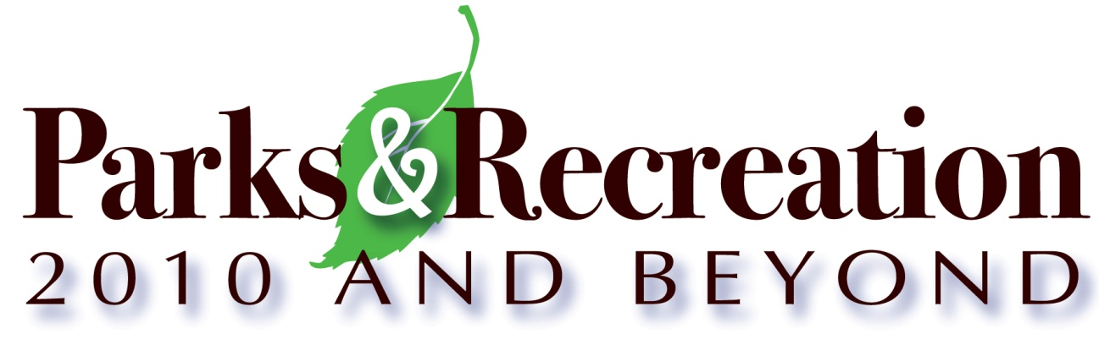
Synopsis of Case Study
Intent of the Project
In the summer of 2008, the Maryland National Parks and Planning Commission undertook an effort to create a long-term vision for parks and recreation within Prince George’s County. This study was designed to include a focus on service provision to 2040, along with a ten-year Strategic Plan and a three-year implementation plan. This study is innovative in the use of 1. A comprehensive and broad-based public outreach process aligned with additional staff and stakeholder needs assessment, and 2. A detailed inventory and composite-values level of service analysis of the facilities and lands owned and managed by the Commission in Prince George’s County.

The purpose of the project was to identify Prince George's County's recreation programs, parks, trails, and open space needs – now and for the future. This planning process included many steps:

PHASE I: INFORMATION GATHERING September 2008-February 2009
Start-up and Determination of Critical Success Factors
Community & Stakeholder Input Process
Inventory and Assessment of Existing Facilities as of 12/31/08
Program Analysis
Statistically-Valid Survey
Demographic and Trends Analysis

Phase II: Findings and visioning March-April 2009
Findings and Visioning Presentations
Staff and Community Meetings

PHASE III: Analysis, Recommendations and Approvals May-November 2009
Presentations of Draft Plans, Public Meetings, and Review
Creation of Detailed Indoor Facilities and Pools Analysis
Revisions and Additional Analysis
Presentations of Final Plans and Approvals

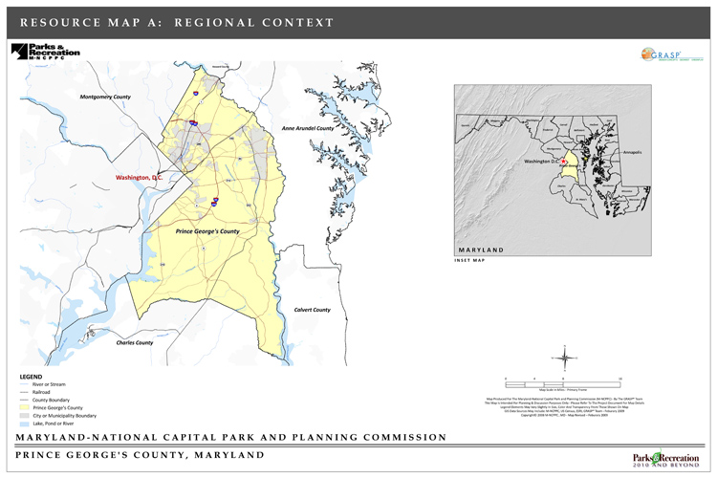

Outcomes and Tools Available Now for M-NCPPC
As part of the Parks & Recreation: 2010 and Beyond project, new quantitative and qualitative information was gathered that was not previously available to staff and decision makers including:

- Updated demographic information overall and by sub-area.
- National and regional trends related to M-NCPPC’s offerings in Prince George’s County.
- Results from the public meetings and focus groups on a vast array of topics.
- Staff and stakeholder input.
- Results from the statistically-valid survey overall and by sub-area.
- Detailed inventory of all department components by sub-area.
- Composite-Values Level of Service Analysis for the all relevant components owned and managed by the Department and for select key components (including indoor center spaces and pools).
- Analysis of the Department’s responsibilities, services, and capabilities, organized for future strategic implementation into six overriding Vision Themes:

THEME 1 - Appropriate level of service for parks and facilities to meet diverse community needs
THEME 2 - Natural areas, trees, and waters that endure and captivate
THEME 3 - Recreation and culture that inspires healthy lifestyles and a sense of community
THEME 4 - Safe and accessible places and programs for play, relaxation, and enjoyment
THEME 5 - Community engagement and collaborations that maximize resources
THEME 6 - A sustainable organization to provide quality services and facilities

The elements of the Parks & Recreation: 2010 and Beyond Plan include the following three report volumes:

1. Needs and Resource Assessment – The Findings and Background documents.
2. 2040 Vision & Framework – the Ten Year Strategic Plan and 2040 Vision Recommendations.
3. FY2010 to FY2013 Implementation Plan - Staff-detailed Three-Year Implementation Work Plans.

Costs: MNCPPC hired GreenPlay, LLC to help facilitate the process and create the plan documents. Total consulting cost was $323,526 plus staff time for the full project.

Savings: Total savings are not yet known, but the Commission saves indirectly through prioritized capital, operational, and maintenance costs focusing. Certain objectives from the planning process have cost-saving evaluation as part of the desired outcomes – to be determined.
Innovative Characteristics
The Department (like most agencies) had never completed a full strategic planning and visioning effort to identify top long term focus areas. The process was designed to highlight the key issues for attention, along with capital priorities and tools that can help make decisions.
In addition, the process utilized Composite-Values Method for Level of Service Analysis to help determine and provide tools to ascertain how many and where future facilities should be located. This process is detailed, dynamic, uses GIS-based programs along with MS Access and Excel to analyze the quantity, quality, walkability, access and geographic locations of all facilities. This analysis also accounts for sub-area analysis and analysis adjusted for population density throughout the county.
Sample Analysis Map (Perspective)
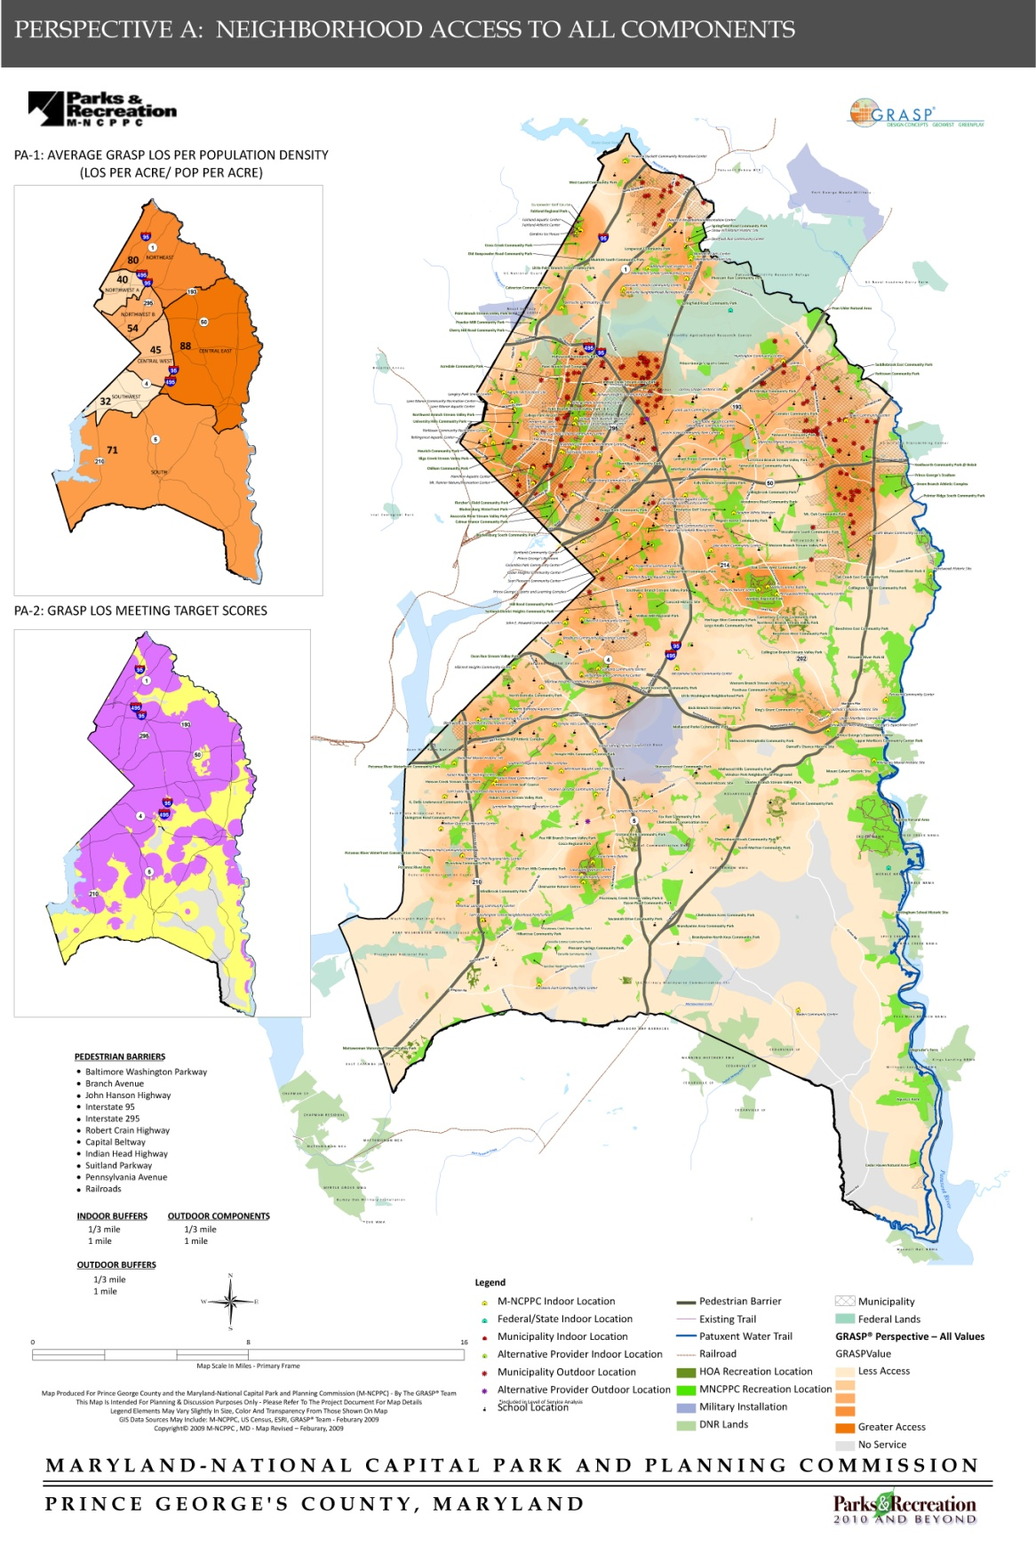

Obstacles
M-NCPPC is a large organization covering a broad geographic area; doing this type of comprehensive community outreach and analysis for an organization of this size is daunting, to say the least. The process had to be tightly controlled and time-sensitive, while also completely open to community and staff input at all levels. The case study will give an overview of some of the key challenges and how they were handled.

Results
This large project has been completed successfully and staff are moving forward to implement the work plans. The Commission has a vision for the future that is focused, equitable, and based on sound data and community input.

1. Innovations / Creativity
This project helped to improve the organization by providing focus areas and strategic objectives for an agency that is very large. This is the first time a strategic planning effort of this magnitude had been completed, and it required strong identification of stakeholders, a detailed community and staff input process and timeline, with many well-managed components and tasks.
The project utilized state-of-the art Geographic Information Systems (GIS) integration for a detailed digital inventory, which provided accurate data for utilizing composite-values based level of service analysis to ascertain the current and project future service from all components and facilities that are owned and managed by the department.
As key issues were identified, the project also included detailed analysis of indoor facilities. Level of Service Analysis of indoor recreational facilities is a newer type analysis and not much has been done in this industry previously. Through the use of a national consultant that has expertise in creating systems for analysis of these types of specialized components, M-NCPPC was able to identify objective priorities, including a change in the indoor service delivery model. This type of analysis helps to create a consistent rational basis for decision making that can be understood by both the public and the Board.
For example, to look at potential priority locations for future facilities, decision matrices, that summarize key indicators for existing indoor facilities were compiled.

Sample Indoor Analysis Matrix
Sub Area | 2007 Population* | SF of Ctrs | SF/pop. | % w/in 1 mile | LOS pop density | LOS-Pop Gaps | **Pop Growth | Priority for new facilities
NW A | 101,214 | 70,216 | 0.7 | 92.8% | 5.55 | no | 14% | Secondary
NE | 119,830 | 86,576 | 0.7 | 45.6% | 33.58 | yes | 8% | Secondary
NW B | 102,760 | 24,121 | 0.2 | 94.9% | 16.00 | no | 4% | Higher
CW | 101,228 | 372,079 | 3.7 | 84.1% | 23.86 | no | 3% | Lower
CE | 165,278 | 124,284 | 0.8 | 36.4% | 55.02 | yes | 23% | Higher
S | 139,868 | 88,946 | 0.6 | 15.6% | 42.34 | yes | 29% | Higher
SW | 98,592 | 107,190 | 1.1 | 77.0% | 9.42 | no | 6% | Secondary
Total | 828,770 | 873,412 | 1.1 | 43.2% | 35.30 | YES | 12%

In the presentation, we will share the processes utilized to manage the inventory and the level of service, along with providing sample perspectives (analysis maps) , charts, and mechanisms that may be duplicated for other communities.
A Private Consultant was utilized and the Principal in Charge, Teresa Penbrooke, CPRP, will co-present.
Contact: GreenPlay, LLC
3050 Industrial Lane, Ste 200
Broomfield, CO 80020
Phone Toll Free: 1- 866-849-9959
www.GreenPlayllc.com
Teresa Penbrooke, CEO and Founder Email: teresap@greenplayllc.com

2. Citizen Outcomes
This plan is a result of the collective efforts of engaged residents, stakeholders, staff, and leadership. Over 4,500 members of the public along with elected officials, staff, and other stakeholders contributed to the vision and strategies laid out in this plan, and greatly improved the residents’ access to the agency. At each stage of the planning process, community members and staff contributed their thoughts and ideas, helping to identify key issues and recommendations. In addition, a Steering Committee made up of a cross-section of county stakeholders guided the project along with a staff project team. Specific opportunities for input included the following:
Surveys
A statistically-valid survey of residents in Prince George’s County was mailed to 14,000 randomly selected county households for the Parks & Recreation: 2010 and Beyond project. The survey provided input from a representative sample of residents and was a reliable method to get input from non-users of the M-NCPPC parks and recreation system in Prince George’s County. Surveys were also available in Spanish. An open web-based survey was available to any interested county resident or stakeholder. A total of 1,429 completed surveys were completed, with solid representation from each sub-area of the county.

Focus Groups
Forty external focus groups were held gaining input from 400 stakeholders during the informational gathering phase of the project. Input was gained from a variety of groups throughout the county with different diverse interest areas. In addition, input was also gained from a cross-section of staff representatives in focus groups and individual interviews.

Public Meetings
Broad outreach was made at each stage of the project to engage residents in sharing ideas and shaping the Parks & Recreation: 2010 and Beyond vision and plans. A total of fourteen public meetings were held throughout the county.

Stakeholder Input Regarding Community Needs and Expectations
Key themes identified for further improvement included:
- Improving perception of safety and security.
- Increasing marketing and communications efforts.
- Improving equity and distribution of programs and facilities, along with transportation and access capabilities.
- Offering a variety of programs for all ages, ethnicities, and abilities.
- Partnering with schools, faith-based organizations, and other non-profit, for-profit and governmental agencies.

Community health is a primary focus for the agency, and many objectives are aligned with this type of outcome objective. Performance measures were created that tie directly to this type of desired community impact.

3. Practical Applications and Applicable Results
The primary reason we are submitting this project for a case study is to share the process and the outcomes that they can achieve. All aspects of this project will be helpful to other local governments, whether large or small. The use of a well-organized community input process is key for all well run agencies, and the composite-values level of service analysis, while primarily used for parks and recreation facilities in this project, can be adapted for looking at service for all governmental amenities. It is especially helpful when trying to analyze access, potential geographic location of facilities, trailhead analysis, and walkability application.
For this Case Study session, we will give an overview of the innovations that were utilized, along with an analysis and breakdown of the pros and cons of different portions of the project. Sample analysis perspectives and decision-making matrices will be shared in the hope that learning about a process like this will help other communities improve their service provision.

4. Case Study Presentation Format
This case study presentation format will include:
- PowerPoint slides, interactive lecture, and outline featuring an introduction to the project and key process steps
- Handout materials to support the key points and provide examples for them to take back to their agencies

