The A.V.
Symington Projects

Submitted by:

The Town of Leesburg, Virginia
Rich Williams
Director
50 Ida Lee Drive, N.W.
Leesburg, VA 20176
703-737-7140
703-737-7148 fax
rwilliams@leesburgva.gov

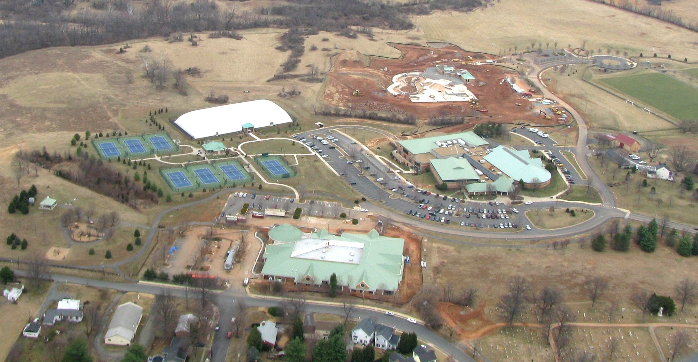



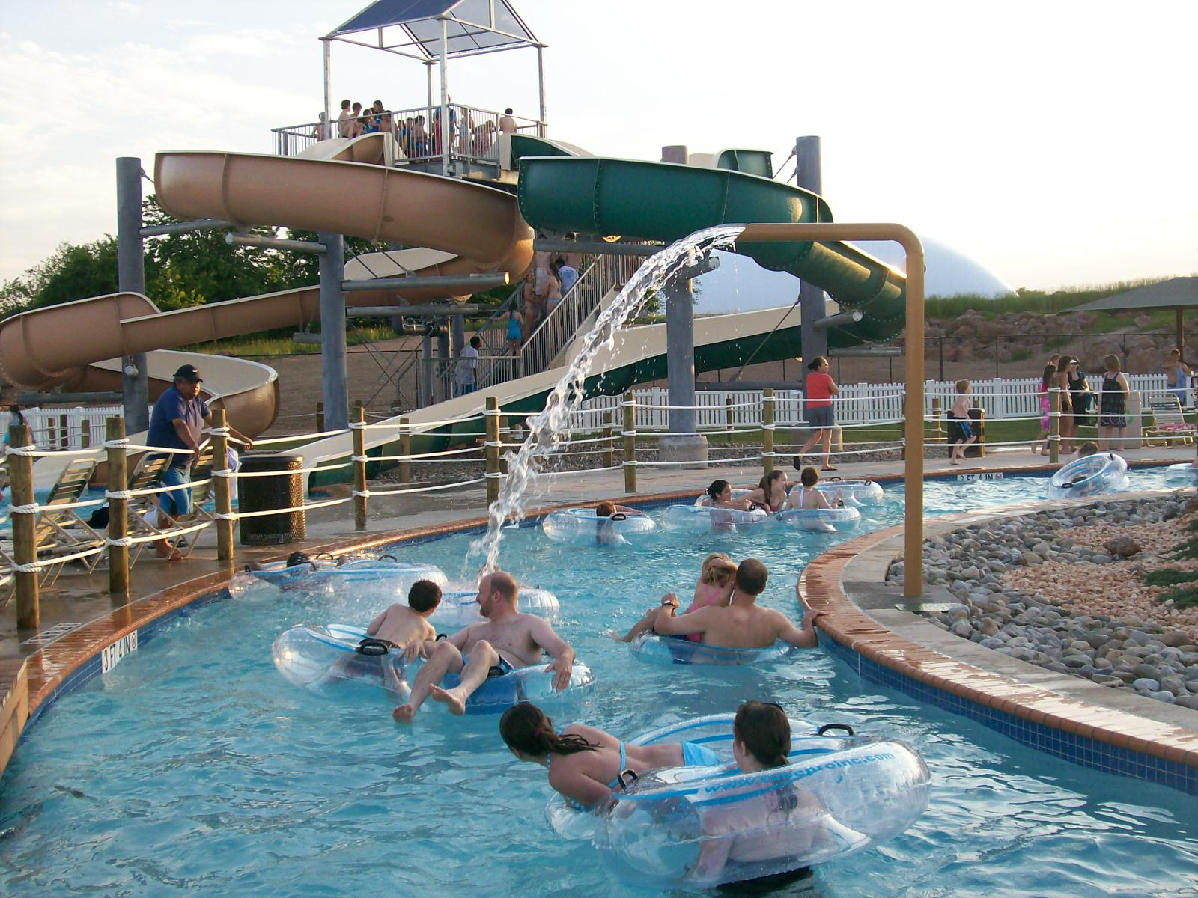

The A.V. Symington Projects

Introduction

In the spring of 2004, the Town of Leesburg Parks and Recreation Department was notified of a $4.5 million donation to be used at Ida Lee Park. The donation was made possible by A.V. Symington, an avid swimmer at Ida Lee Park Recreation Center. Mrs. Symington stipulated that the money be used exclusively for the purchase or construction of improvements and/or purchase of equipment and services for public recreational and educational purposes at Ida Lee Park Recreation Center. After receiving the donation, the Town of Leesburg took a proactive step in identifying the recreational needs of the community and created an innovative way to finance the projects indentified through several public input methods. The Town of Leesburg Parks and Recreation Department staff and members of the Parks and Recreation Advisory Commission worked diligently with the public to determine the best usage of the donation. After conducting a telephone survey and several community input sessions, four projects were identified: expansion of the recreation center; construction of an outdoor pool; development of an indoor tennis center; and acquisition of adjacent land. In April 2005, Mason-Dixon Polling and Research conducted a telephone survey of 625 adult Leesburg residents to determine the level of support for the four potential projects. The outdoor pool received an overall support of 82%, the expansion of the recreation center came in second with 74%, acquiring the adjacent land received 68%, and the indoor tennis center received 44%. After conducting a feasibility study in the summer of 2005, the expansion of the recreation center was dropped from serious consideration due to the cost of construction and lack of financial performance. A financial model demonstrated that the remaining three projects were financially possible as the outdoor pool and indoor tennis center would generate revenue. The Town was grateful for the generous donation, but $4.5 million alone could not meet all the needs. With a market analysis demonstrating sufficient demand for all three projects, the Town came up with an innovative financial plan to ensure the needs of the community were met. The Town stands by its vision statement to “exceed expectations” as well as its strategic plan goals of community development and financial accountability. Thus, was the motivating factor to make all three projects a reality. With the help of the Town’s financial advisor, a financial plan was devised to maximize the donation. The financial plan allowed for a maximum expenditure of $1 million for the acquisition of adjacent land, $7 million to complete the outdoor pool, and $2.5 million to add the indoor tennis center. While the Town of Leesburg is still actively negotiating the acquisition of 40 acres adjacent to Ida Lee Park, the indoor tennis center opened in January 2008 and the outdoor pool opened in May 2009.

History

At the time of the donation there were 24 private outdoor pools (including those owned by apartments, condos, HOA’s, and clubs) within the Town of Leesburg, yet not a single public outdoor pool existed. In assessing the need for an outdoor pool, the Town identified that of the 12,165 households within town limits, 6,766 of them did not have access to an outdoor pool. These numbers clearly indicate the need for, and the population being served by, an outdoor pool. And to ensure overwhelming success, amenities were included that would generate multiple visits to the facility. With the greatest percentage of support for the outdoor pool, a wide variety of features were chosen to ensure there is something for everyone no matter the age.

At the time of the donation, a local privately owned tennis club had the only indoor tennis courts available within Town limits. With the club closing permanently in the spring of 2006, pressure fell on the Town to meet the needs of the citizens and provide these services in the club’s absence. Expanding the tennis facilities and programs, with the help of the donation, could not have come at a better time.

While indoor tennis was the lowest priority identified, the knowledge of the tennis club closing and knowing the demand from residents and non-residents would be immense, studies showed that four to five indoor courts would support the need of the community. Initially, the Town of Leesburg discussed covering several existing tennis courts. However, the tennis community expressed strong support for additional courts that could be used year-round. An air-supported structure covering four new courts proved to be the best long-term solution and would expand the Ida Lee Park Tennis Center to 11 courts.

Improvements were made to the existing seven outdoor courts as well. In January 2008, the department completed a renovation of the Ida Lee Park Tennis Center including the lighting of the seventh outdoor court and repainting all outdoor courts in U.S. Open blue. The existing outdoor tennis pavilion was enclosed to provide year-round restroom facilities and a player’s lounge. To link the outdoor tennis courts, tennis pavilion, and the new indoor center, a decoratively lighted walkway was installed. The improvements to the Ida Lee Park Tennis Center represented a unique opportunity to improve our existing facilities while also creating a new indoor playing experience for our community. The goal of the project was to provide the highest level of experience for tennis players while making the best use of all resources.

Finance
Once the top three projects were identified for the A.V. Symington donation, staff then prepared a financial plan that allowed for maximum project development with minimal tax dollar impact. A package of three revenue sources was developed. This package consisted of the $4.5 million from the Symington donation, $1 million of a reallocated proffer from a local multi-use land developer, and an estimate of $225,000 of annual net operating revenue. These funds were applied towards the purchase of Bond Anticipation Notes (BAN) in the amount of $10 million. For interim financing, the payment for the interest only BAN’s will be paid for by the annual interest earned from the Symington donation and the annual payment from the land developer’s proffer. After five years, the permanent financing will begin. The $10 million principal for the BAN will be paid off with the $4.5 million of the Symington donation principal and the remaining $600,000 of proffer funds. This will leave the Town with a $5,150,000 general obligation bond for 20 years. Annual debt service on the bond will amount to $375,000. The net operating revenue from the tennis and pool operations will be used to pay a portion of the debt service in a payment of $225,000. The remaining balance of $150,000 will be paid for by the general fund. As the financial performance of these facilities improves, this amount will be reduced proportionally.
Interim Financing Permanent Financing
-Bond Anticipation Notes | $10,000,000
-Annual interest-only payments | $250,000
-Annual Int. Earned-Symington | $170,000
-Annual Payment from KSI Proffer | $80,000
Total | $250,000
Project costs | $10,500,000
-Minus: Symington principal | $4,250,000
-Minus: Remaining KSI proffer | $600,000
Total amount of G.O. Bonds | $5,150,000
-Annual debt service | $375,000
-Minus: Net operating revenue | $225,000
Total – required from Town | $150,000

T
T

The operational budgets for both projects were also streamlined to provide efficient running of the facilities. For example, only one new full-time staff member has been added to the department. The decision was made to hire a head tennis professional to oversee the new tennis facility and programs. This allowed for the expansion of the department’s existing offerings and raised the level of service as the members of the privately owned tennis club were absorbed. For the outdoor pool, the current aquatics team adjusted their duties to include the management of the third pool. Several other cost-saving measures were taken into account in order to absorb the new facilities into current staff’s work schedules, such as the department’s grounds crew, which designed and installed the landscapes of both facilities, and chose plant material and grasses that require minimal maintenance. The concession stand at the outdoor pool was contracted out to minimize costs as well.
With careful and thorough development of a sound fiscal plan, the Town was able to provide for two large-scale community recreation projects. In doing so, we have been able to expand our services to the residents while limiting the burden to the taxpayer.

Conclusion
The risk associated with planning and developing this innovative financial plan was that the plan would not be a viable one. To date, the two new facilities have already demonstrated significant financial success. Since its grand opening, the Ida Lee Park Tennis Center has been well received by the community. The facility was voted the “Best Tennis Courts in Loudoun” for 2008 and 2009 by the community through a poll in the local media. The addition of lighting to the seventh outdoor court and the creation of the A.V. Symington Indoor Tennis Center allows for just under 32,000 court hours of play for public use throughout the year. Participation in our tennis programs has increased almost 400%. Another measure of success is the revenue generated; for fiscal year 2009, the Town will have a net of over $200,000, which is 60% over projected budget.

Though the pool has only been open for one summer, it received significant support from the community. Originally we estimated that the pool would see 750 visitors per day, yet in reality we received about 850 to 1,100 visitors per day. Families, teens, college students, summer camps, and seniors alike enjoyed the pool. As one mother said about the vast amenities and fun, relaxing environment at the A.V. Symington Aquatic Center, “My kids think they are at a resort on vacation.” We recognized that only one summer season has past, but if this trend continues as we anticipate, we will far exceed our expectations.

The Town of Leesburg’s financial plan has demonstrated a more efficient and innovative way of delivering government services and will give other government agencies a successful example of how to develop new facilities with little to no cost to their constituents. We hope to be a bench mark to other municipalities to follow our operating model so that financial cost will not be the limiting factor in providing services to meet the recreational needs of their citizens. The facilities built by the Town of Leesburg were not overly complicated in concept or design. They were designed to meet the needs of the community while providing a high-quality experience. Hopefully, this will have others thinking about the positive impact they could make in their communities with a similar financial plan.

