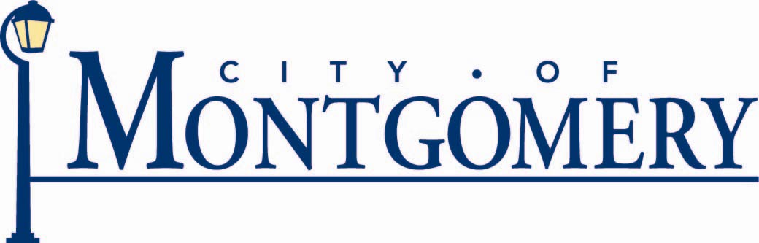

City of Montgomery, Ohio
10101 Montgomery Rd.
Montgomery, Ohio 45242

Bob Nikula
Public Works Director
Phone: (513) 792-8311
bnikula@ci.montgomery.oh.us

The City of Montgomery embraces the High Performance Organization model of simultaneously providing outstanding customer value, high product and service quality in a sound financial manner to its residents, businesses and visitors. The City of Montgomery has created a mission statement of “Taking Responsibility Together to Provide Superior Services” along with the creation of supporting statements that include but are not limited to: organizational value statements, employee expectations and leadership philosophy that emphasize a commitment to responsive, high quality service, employee leadership at all levels of the organization, decision making based on creative problem solving, collaboration, continuous improvement, and stewardship of the entire organization.

The City of Montgomery has a tradition of innovation that includes taking action and responsibility together in providing the aforementioned superior services to our community. Our goal of providing superior services also includes a long-standing tradition of environmental stewardship in the areas of solid waste disposal including prudent waste stream direction toward recycling, composting or landfill operations.

A City service that nearly every resident utilizes is the curbside waste collection program. This curbside program provides waste and recycling collection for every single and two-family residence in the community. Montgomery’s waste collection was modified approximately three years ago by transitioning to the first fully automated waste collection program in Hamilton County, Ohio.

The automated waste collection program was successful in terms of City staff working with the collection contractor and educating our residents about the benefits of the automated collection program. This education program included registering residents’ trash collection containers so that every address in the community had a uniquely numbered trash collection container. Every eligible household was given the opportunity to select one of three (3) sizes of containers that would best serve their needs. The education program continued over a period of several months and included information about where to position containers, the significant changes that the automated program would have on worker safety in addition to helping control costs of providing waste collection to the community.

The success realized by the automated waste collection program led to the City of Montgomery to be nominated by Rumpke Consolidated, the City’s waste hauler to the Hamilton County Solid Waste District for a RecycleBank “pilot program” the cost of which was partially funded through Hamilton County. The RecycleBank program in Montgomery, OH represented the first time in the Midwest that this curbside recycling collection was made available to residents. The program includes technology in collection containers along with close scrutiny by collection personnel that tracks the amount of recycling at individual households. Each household is eligible for rewards based on the weight of recyclable material they place in collection containers. The program rewards are provided in the form of coupons or discounts at participating retailers that choose to “partner” with the “RecycleBank” Program.

The nationwide RecycleBank Program incentive program appeared to be a logical way for Montgomery to encourage residents to recycle more items by providing rewards based on for participating in curbside recycling.

Although the City of Montgomery provides waste and recycling services to residents at “no charge” through the City’s “General Fund” the waste collection program involves a significant expenditure from the City’s operating funds. City staff felt the automated waste collection and RecycleBank programs offered residents in the community an innovative approach to recycle more and hopefully redirect some of the solid waste stream from landfills to recycling facilities. If waste directed to landfills was reduced by increased recycling it was theorized that the City of Montgomery would save money during subsequent waste collection contract periods as waste haulers would see a positive shift that more material was being recycled and less was directed to landfills and thereby offer lower rates for solid waste collection in future years. City staff also recognized that an increase in recycling and a decrease in landfilling was another step in demonstrating true environmental stewardship!

While The City of Montgomery was traditionally recognized as one of the top ten communities in Hamilton County for its residents’ recycling rates our staff felt that the RecycleBank Program would move the community forward in terms of recycling rates with the goal of moving from #6 in the County to #1.

Staff understood that educating residents to recycle more would require support, feedback and encouragement. In typical Montgomery fashion, the RecycleBank Program utilized extensive planning, education and follow-up as described in the “Plan-Do-Check-Act” model. The foremost goal for the RecycleBank Program that was implemented in late October 2008 was to increase the weight of recycled materials with a corresponding drop in the weight of solid waste placed curbside for collection directed to the local landfill. Our staff theorized that educating and rewarding residents was an excellent opportunity to increase recycling rates.

Although over 23% of the total weight of solid “waste” placed by curbside by residents for waste collection was directing to recycling facilities in 2008, City staff felt confident that this rate could be increased in 2009 by recommending to City Council that the City of Montgomery participate in the Hamilton County Pilot Program beginning in late October 2008. At the time of this recommendation staff committed to educate the residents of the community about the benefits of RecycleBank and to collect data on the City’s waste and recycling collection programs.

With this as background, the City of Montgomery is able to report that the results of the first year of the RecycleBank Program have met or even exceeded expectations. As predicted recycling tonnage has increased and the waste directed to landfills has decreased. The change in our residents’ use of the City’s solid waste collection program when the implementation of RecycleBank began in October 2008 is compelling. During the twelve month period (November 2007-October 2008) that immediately preceded the RecycleBank Program a total of 4,391.54 tons of waste was directed to the landfill while 983.88 tons were directed to a recycling center. In the twelve month period (November 2008-October 2009) following the start of the RecyleBank Program in Montgomery landfill tonnage was reduced to 3,581.26 tons while the recycling tonnage was increased to 1,481.28 tons.

As the population in Montgomery was consistent during this two year period as the community is essentially “built-out”, the positive change to redirect waste from landfilling to recycling is most likely the direct result of the RecyleBank Program. The change in the corresponding 12 month periods between 2007-08 and 2008-09 shows that residents increased the weight of materials recycled by 51% while reducing the amount of weight of materials directed to landfill by 18%!

In an effort to find out more about the resident’s perception about the RecycleBank Program every household participating in the City’s RecycleBank collection program was provided the opportunity to respond to a survey during the August-September 2009 timeframe about this relatively new and improved recycling program. Information was collected in Montgomery’s 2009 Recycling Survey that included a 37% response rate. This response rate is an excellent indicator that data collected provides a reasonably accurate representation of the overall community sentiment about the RecycleBank Program.

Several significant lessons were learned during the year since RecycleBank began. While staff theorized that recycling would increase because of the reward system, the survey response indicated that while important the rewards program was not viewed as importantly as was the fact that with the RecycleBank program they were provided a larger recycling container with wheels and a lid. Over 70% of the responses indicated that the most important aspects of the RecyleBank Program are a wheeled and enclosed container with 52% indicating that rewards were the most important.

City staff believes that the RecycleBank Program combines improved convenience to residents combined with education, information and rewards that resulted in a significant change in how our residents view and dispose of their “trash”. That effort has resulted in an improved balance between solid wastes directed to a landfill as opposed to a recycling facility. The inception of the RecycleBank Program in late October 2008 as well as ongoing communications and information from City of Montgomery staff and the City’s Environmental Advisory Commission have been instrumental in increasing recycling rates while reducing landfilled materials generated in the community.

The increase in recycling and reduction in land filled material is clearly demonstrated by the preceding information and is also reflected in the fact that the Hamilton County (OH) Solid Waste District recently reported that Montgomery increased its percentage (by weight) of recycling from 23.33% and 6th best in Hamilton County during the last half of 2008 to a 28.44% rate in the first half of 2009 moving Montgomery to #1 in Hamilton County, Ohio.

All indications are that the City of Montgomery’s proactive approach in improving its solid waste and recycling programs for its residents have achieved the desired results of increasing recycling and reducing waste that demonstrates true environmental stewardship.

It was through perseverance and dedication that this innovative approach for solid waste disposal was implemented in Montgomery Ohio. Our public and private partners recognize that the City’s mission statement of “Taking responsibility together to provide superior services” not only involves this mindset throughout our organization and community but also includes building strategic partnerships with our public and private partners that complement their operating and business models as well.

Providing superior services in Montgomery Ohio is demonstrated in many ways. It does however always involve basing our services on our high performance organizational principles of providing outstanding customer value, high product and service quality in a sound financial manner. In this specific but well planned example one can see that creative problem solving, innovative thinking, information and education along with forming strategic partnerships allowed the City of Montgomery and its residents to increase recycling tonnage while simultaneously reducing landfill tonnage was completed in an effective manner with excellent results.

