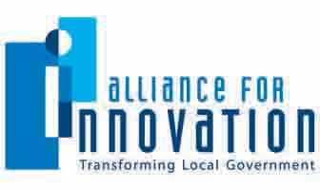
Brandi Allen
Conferences & Education Director
Alliance for Innovation
ballen@transformgov.org
602- 496-1097
COVER PAGE

Innovation Study Title _____Douglas L. Smith Middle Basin Treatment Plant____ _____Cogeneration Project____________________________
Category _____Sustainability__________________________________
Jurisdiction Name ____Johnson County, Kansas__________________________
City/County Manager ____Hannes Zacharias________________________________
Population ____550,000_________________________________________

Submit Innovation Study for an Alliance Innovation Award Yes [ X ] No [ ]
Alliance member jurisdictions only. Learn more about the award program at transformgov.org/en/about/innovation_awards

Project Leader/Primary Contact

Name _____James Joerke__________________________________________
Title _____Sustainability Program Director__________________________
Phone Number _____913-715-1120__________________________________________
Email _____james.joerke@jocogov.org______________________________
Mailing Address _____111 S. Cherry, Suite 2100, Olathe, KS 66061_______________

Presentation Team Member #1

Name ____John O’Neil____________________________________________
Title ____General Manager, Johnson County Wastewater_____________
Phone Number ____913-715-8570___________________________________________
Email ____John.O'Neil@jcw.org____________________________________
Mailing Address ____11811 S. Sunset Dr. #2500, Olathe, KS 66061________________

Johnson County, Kansas
Douglas L. Smith Middle Basin Treatment Plant Cogeneration Project

Synopsis

The Government of Johnson County, Kansas, has made an organization-wide commitment to operate as sustainably as possible and to make decisions with a focus on the “triple bottom line” of environment, economics and social equity. Since 2004, a staff committee representing nearly all 40 county departments and agencies has met regularly and worked actively on initiatives related to sustainable building construction and operation, energy conservation, waste reduction and recycling, environmentally preferable purchasing, and fleet and clean fuel issues. In 2007, a sustainability steering committee composed of department directors and a county commissioner was formed to provide more formal oversight of and leadership in the county’s sustainability efforts. The following year, the county hired its first sustainability program director, who oversees and coordinates sustainability projects throughout the organization.

In 2007, the Johnson County Board of Commissioners passed a resolution directing staff to conduct an inventory of organizational and community-wide greenhouse gas (GHG) emissions. The resolution also established goals of reducing organizational GHG emissions to two-thirds of 2005 base year emissions by 2020, and reducing community-wide GHG emissions 80 percent by 2050. Both inventories were completed in 2009. The data show that GHG emissions from wastewater operations make up the single biggest portion – 44 percent – of the organizational inventory.

Recognizing its contribution to the organizational inventory, Johnson County Wastewater (JCW) has taken a leadership role in efforts to achieve GHG reductions. JCW has completed a system-wide energy audit to identify opportunities for making its processes less carbon intensive. Even before the audit began, staff identified the Douglas L. Smith Middle Basin Treatment Plant as a prime candidate for a cogeneration project. When the American Recovery and Reinvestment Act was passed in early 2009, plans for the project were complete, which enabled JCW to secure stimulus funding for the project. Construction began in May 2009 and was completed in early 2011.

The goals of the project were 1) to increase the solids handling capacity of the Douglas L. Smith treatment plant, 2) to use methane from digestion of biosolids and fats, oil and grease from restaurants to generate electricity, 3) to reduce the county’s carbon footprint and 4) to reduce utility costs for the wastewater department.

JCW added an anaerobic digester to increase the solids handling capacity of the Douglas L. Smith treatment plant and constructed a receiving station for waste fats, oil and grease (FOG) from area restaurants and industries. The use of FOG has increased by over two times the amount of methane that the plant’s four digesters produce. The methane powers a generator that was installed as part of the project. At peak production, the generator is expected to produce enough electricity to supply half of the power needs of the entire treatment plant, reducing the county’s carbon footprint by 9700 metric tons per year and saving ratepayers $500,000 annually in utility costs. The project is also estimated to have saved or created 56 jobs.

The $17.8 million project was funded through the American Recovery and Reinvestment Act, and nearly 50 percent of this amount is eligible for principal forgiveness. The U.S. Environmental Protection Agency is the lead federal agency on the project, and the funds are being administered by the Kansas Department of Health and Environment.

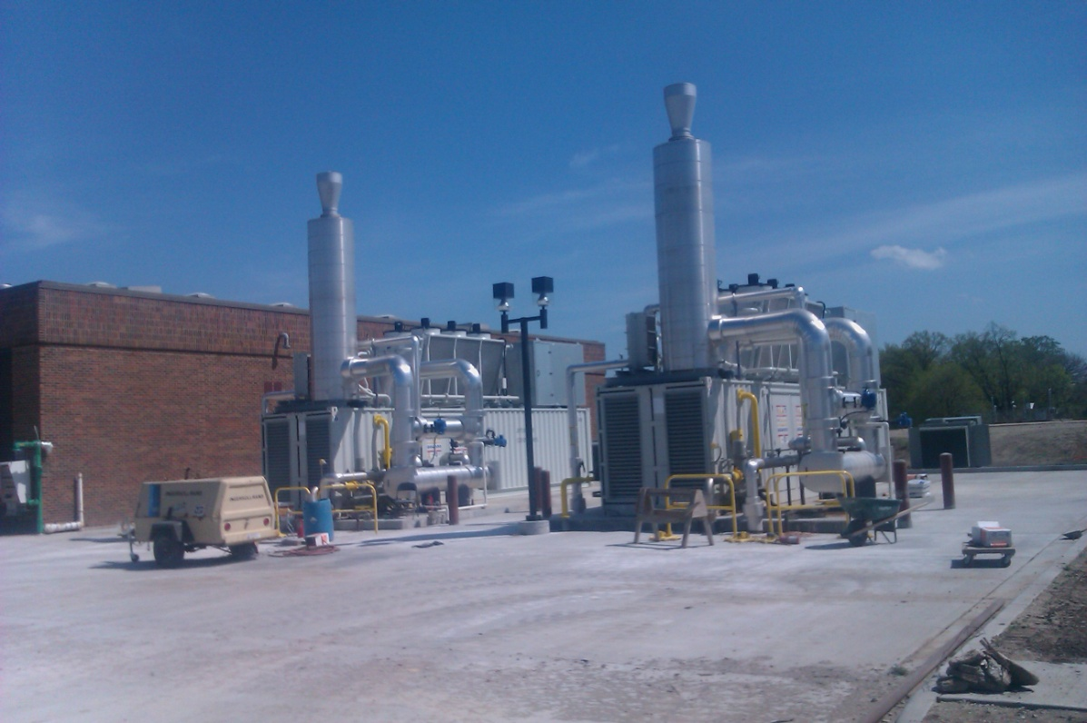

Gas Turbines

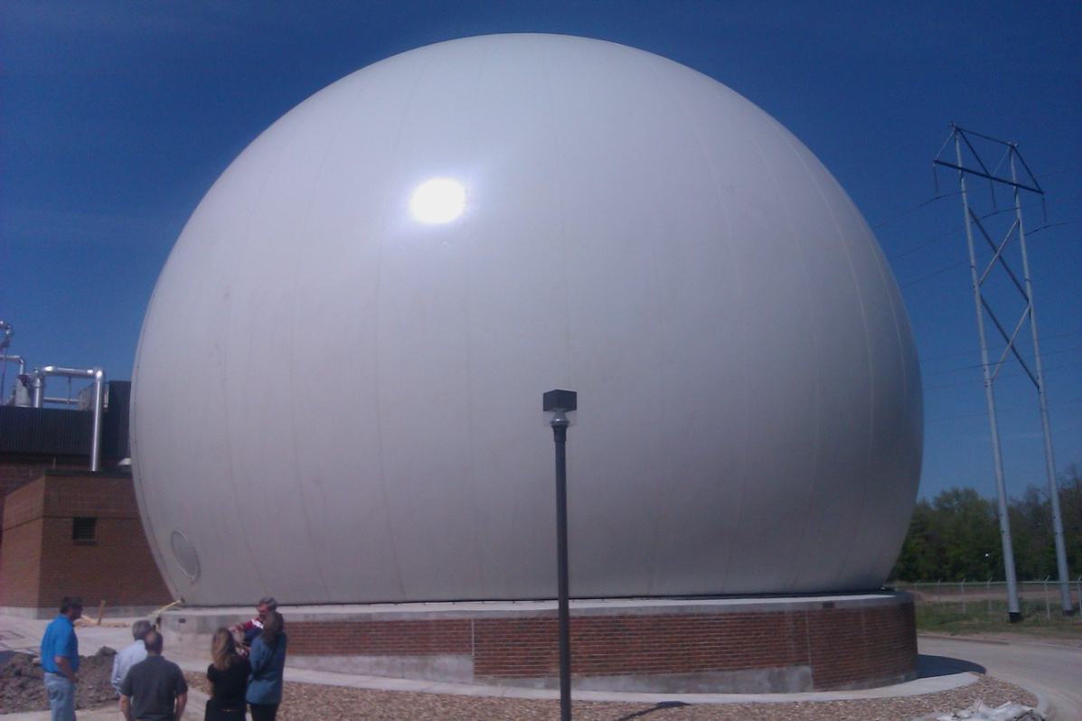

Gas Storage Bubble

1. Innovation/Creativity
- How did the idea/program/project/service improve the organization? It reduced carbon footprint and reduced electrical costs of operating the plant. Additionally, the residual solids were recycled through a land application program.
- Were new technologies used? Yes, to the extent this was a novel combination of existing technologies used to handle a troublesome waste (restaurant and industrial grease), and turn it into energy. There are only a handful of similar facilities across the country.
  - If yes, what methods and/or applications were implemented? A number of technologies used, including a unique indoor FOG receiving station, gas bubble storage and containerized co-generation units.
- Was a consultant used? Yes.
  - If yes, describe their involvement; HDR and CH2M Hill provided planning, design and oversight of construction.
  - Identify the consultant and/or firm, including contact information HDR/CH2MHill, Dale Gable, Dale.Gabel@CH2M.com.

2. Outcomes Achieved
- What customer/community needs and expectations were identified and fulfilled? A convenient location for disposal of restaurant FOG was identified and fulfilled. There was only one other facility in the Kansas City Metro area accepting these wastes. Over 90% of Johnson County restaurants are closer to the new facility than the existing one, greatly reducing travel miles logged by haulers pumping out restaurant grease interceptors.
- Has service delivery been enhanced? Yes, there is reduced cost for haulers and the restaurants they serve.
- Did the initiative improve access to your government? No.
  - If yes, how?
- Has the health of the community improved as a result? Yes.
  - If yes, how? The project is generating public health benefits by reducing greenhouse gases, as well as tailpipe emissions associated with hauling FOG.

3. Applicable Results and Real World Practicality
- What practical applications will be shared? Most wastewater treatment plants have anaerobic digesters that are the key to replicating what we have done. We have simply added the facilities to accept other wastes that greatly increase methane production in the digesters and to use the methane to generate electricity to power the plant.
- How applicable is the idea/program/project/service to other local governments? Very.
- What results/outcomes will you share? We can share operational results, lessons learned in the design of the facilities, and how to develop a market for wastes that can help generate more methane.
- Include any applicable performance measures, if any. Methane production with and without wastes. Amount of electricity generated. Gallons of FOG waste recycled into electricity.

4. Innovation Study Presentation
- Describe your innovation study presentation. Our presentation would incorporate PowerPoint, video and handouts.

