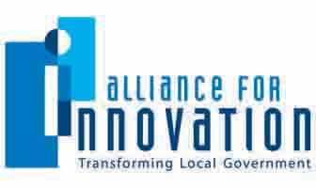
Brandi Allen
Conferences & Education Director
Alliance for Innovation
ballen@transformgov.org
602- 496-1097
COVER PAGE

Innovation Study Title Regional Jet Service Revenue Guarantee

Category Community Relationships

Jurisdiction Name City of Manhattan, Kansas

City/County Manager Ron Fehr

Population 52,281

Submit Innovation Study for an Alliance Innovation Award Yes [ x ] No [ ]
Alliance member jurisdictions only. Learn more about the award program at transformgov.org/en/about/innovation_awards

Project Leader/Primary Contact

Name Lauren Palmer

Title Assistant City Manager

Phone Number (785) 587-2404

Email palmer@ci.manhattan.ks.us

Mailing Address 1101 Poyntz Avenue, Manhattan, KS 66502

Presentation Team Member #1

Name Peter Van Kuren

Title Airport Director

Phone Number (785) 587-4560

Email vankuren@ci.manhattan.ks.us

Mailing Address 5500 Fort Riley Boulevard, Manhattan, KS 66502-5497

Presentation Team Member #2

Name Ron Fehr

Title City Manager

Phone Number (785) 587-2404

Email fehr@ci.manhattan.ks.us

Mailing Address 1101 Poyntz Avenue, Manhattan, KS 66502

Presentation Team Member #3

Name Lyle Bulter

Title President/CEO – Manhattan Area Chamber of Commerce

Phone Number (785) 776-8829

Email lyle@manhattan.org

Mailing Address 501 Poyntz Avenue, Manhattan, KS 66502-6005

Presentation Team Member #4

Name Rich Jankovich

Title City Commissioner (former Chair, Airport Advisory Board)

Phone Number (785) 587-2404

Email jankovich@ci.manhattan.ks.us

Mailing Address 1101 Poyntz Avenue, Manhattan, KS 66502

SYNOPOSIS

Intent of the Idea

On March 23, 2009, American Eagle Airlines announced it would begin twice daily regional jet service between Manhattan Regional Airport (MHK) and Dallas-Fort Worth International Airport (DFW), contingent on a commitment from the community to provide incentives. The State of Kansas agreed to fund $2 million over two years to support a Minimum Revenue Guarantee (MRG) to the airline that required local matching funds of $550,000. MRG funds are only expended when the airline does not achieve monthly passenger targets, and any funds remaining at the end of the two years will be returned to the state and local entities.

Securing regional jet service opens important new economic development and tourism opportunities for the region. DFW serves 173 destinations worldwide on 20 airlines and is the third busiest airport in the world with over 1,700 flights per day. Every major city in the continental United States can be accessed from DFW within four hours. The greater Dallas-Fort Worth area is a key alumni and recruitment base for Kansas State University and holds significant business ties for several local companies.

The service has grown to now include three daily flights to DFW and a daily flight to Chicago O’Hare International Airport (ORD). ORD is also among the nation’s busiest airports and a significant International Hub, which opens new business and leisure travel options for the region. The ORD and additional DFW flights were added due to the demonstrated strength of the market, but would not have happened if not for the backing of the original revenue guarantee agreement. On June 21, 2011, the City Commission agreed to waive six months of office rent and fuel flowage fees in exchange for the airline adding a second flight to Chicago. Due to additional airport revenues from the second Chicago flight, the net impact of the fee waivers is approximately $10,000. The second flight to ORD will be added in November 2011.

Length of Time the Idea Has Been Enacted

The MRG was a short-term incentive program, not a long-term subsidy. The new regional jet service began on August 25, 2009, and service was expanded to include Chicago O’Hare International Airport on November 18, 2010. The revenue guarantee agreement expires on August 24, 2011. Due to the success of the program the Airline will continue service after its expiration.
Anticipated and Actual Outcomes
MHK is now the second busiest airport in the state. The charts below show the strong success of the new service for both enplanements and deplanements. To date, only $203,853 has been drawn from the revenue guarantee escrow account. The last draw was in October 2009. Based on the success of the service, it is unlikely that any additional revenue guaranty funds will be drawn before the conclusion of the agreement on August 24, 2011. The remaining funds, including interest, will be returned to the City’s Economic Development Fund and the State of Kansas at the conclusion of the agreement.

MHK Commercial Airline Enplanements
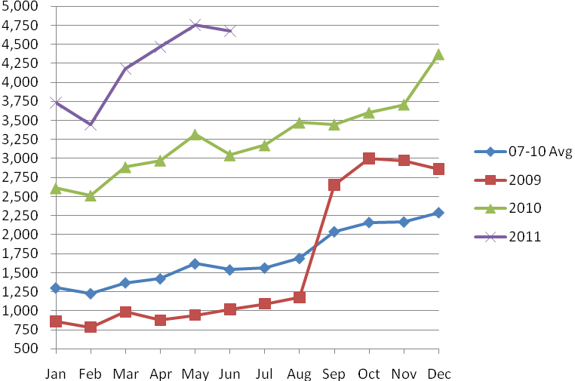
MHK Commercial Airline Deplanements
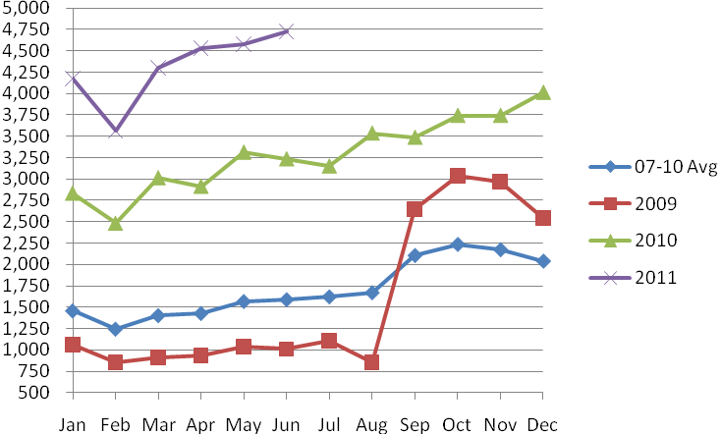
According to the 2010 Kansas Aviation Economic Impact Study, the total employment related to Manhattan Regional Airport is 233 jobs. The total economic impact of the airport was listed at $22.9 million. It is important to note that all of the information for this report was compiled before the advent of regional jet service, so the economic impact today is substantially higher.
Costs and/or Savings

The City Commission authorized $400,000 from economic development funds to be used as follows: $300,000 for airline start-up costs that qualify for the local match to the state funds and up to $100,000 for marketing funds to encourage use of the service. On July 21, 2009, the Commission approved an additional $120,000 of economic development funds to purchase Ground Support Equipment for American Eagle to use in its operation of the service. A portion of this equipment was recently sold to the airline. Proceeds from the sales totaling $69,020 were returned to the Economic Development Fund. On May 4, 2010, the Commission authorized up to $250,000 to meet the local match requirement for the second year of the revenue guaranty. Finally, on August 18, 2010, the Commission authorized $100,000 as a local match for a grant from the U. S. Department of Transportation Small Community Air Service Development Program. The funds support ongoing marketing efforts for the airport and the new jet service.

The Manhattan Area Chamber of Commerce and former Chair of the Airport Advisory Board worked jointly to solicit additional local matching and marketing dollars from counties and cities in the region based on a pro rata share of population and usage of the Manhattan Regional Airport. Commitments of approximately $15,000 were secured from other communities to supplement the marketing campaign, in addition to numerous in-kind donations. Approximately $34,000 was pledged for the revenue guarantee.

Innovative Characteristics

Unlike other incentive programs, funds are only paid from the revenue guarantee if the airline does not achieve monthly revenue targets. Because of their confidence in the strength of the regional market, City Commissioners, the state legislature, and the Governor were willing to take the risk of investing public funds. The majority of those funds will now be returned, plus interest, to the contributing entities, and dollars can be reinvested in future incentive programs.

The revenue guarantee is an ideal example of a regional and intergovernmental partnership. The state made its $2 million lead commitment contingent upon a local matching contribution from the region. This gave the City leverage to convince other cities and counties in the region to contribute. The Manhattan Area Chamber of Commerce also participated as a private sector partner. Early on, various businesses wrote letters of support to the airline to encourage its expansion into Manhattan. The Chamber controls the escrow account for the revenue guaranty funds, thereby acting as a neutral third party for accepting the regional donations. The Chamber also helped facilitate the initial regional marketing campaign for the new service and was able to acquire numerous in-kind promotional and advertising commitments.

Ultimately, the success of the program rested with utilization of the air service. Because so many partners were involved in the revenue guarantee program, a natural constituency developed to market and support the flights.

Obstacles and Results Achieved

City and Chamber staff worked with the Governor’s Office and both political parties and houses of the legislature to secure the state’s investment in the minimum revenue guarantee. Significant research and planning was required to demonstrate that Manhattan’s market would successfully support commercial air service. This pre-planning was essential for the success of the program.

Any new issues/problems, or unintended consequences (things you didn’t expect) realized as a result of the identified effort

The success of the service has increased demand for other airport and transportation services. A major parking expansion was required to accommodate the customer growth at the airport. We still lack effective, reliable public ground transportation that coincides with the flight schedule. Other than vending machines, we do not have a service to meet customer food and beverage needs at the airport. With the growth of additional flights, there is a greater demand on terminal space and airport security. Significant improvements will be required to the terminal in the near future to support this growth.

ADDITIONAL INFORMATION

1. Innovation/Creativity
How did the idea/program/project/service improve the organization?
Were new technologies used?
If yes, what methods and/or applications were implemented?
Was a consultant used?
If yes, describe their involvement; and
Identify the consultant and/or firm, including contact information

Because of the marketing campaign that accompanied the service, we created a new website (flymhk.com) for the airport. The website provides more comprehensive information to the public about air travel services than was previously available. The airport is also now interacting with the public through the social media sites of Facebook and Twitter. Mead & Hunt Consulting assisted with the initial planning and development of the pro forma to demonstrate the untapped market for commercial air service.

2. Outcomes Achieved
What customer/community needs and expectations were identified and fulfilled?
Has service delivery been enhanced?
Did the initiative improve access to your government?
If yes, how?
Has the health of the community improved as a result?
If yes, how?

Regional jet service meets a tremendous need in our community. Both the Chamber and the City have received numerous anecdotal reports of how the service has improved operations for businesses in our community. Access to government was improved through the website and social media outlets.

3. Applicable Results and Real World Practicality
What practical applications will be shared?
How applicable is the idea/program/project/service to other local governments?
What results/outcomes will you share?
Include any applicable performance measures, if any.

The revenue guarantee program could be duplicated by any small- to mid-size airport that hopes to recruit regional jet service. We can share specific performance measures about the growth of the service and the limited payment of revenue guarantee funds. The concepts of intergovernmental and public-private cooperation can be cross-applied to many real world municipal challenges.

4. Innovation Study Presentation
Describe your innovation study presentation.

We plan to have a diverse team of presenters representing the City, Manhattan Regional Airport, Manhattan Area Chamber of Commerce, and the Airport Advisory Board. We will likely prepare a powerpoint presentation to overview the program, but will leave the majority of time for an interactive discussion.

