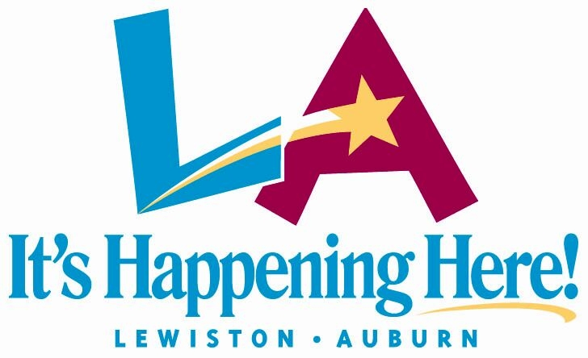
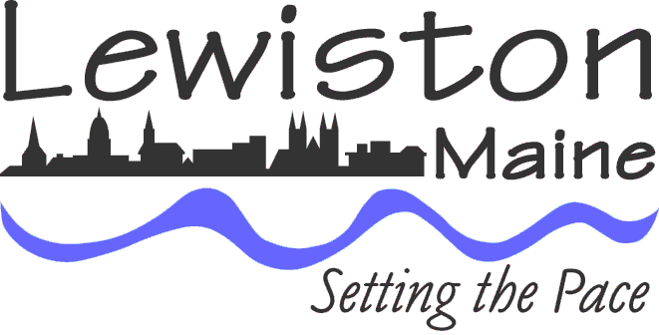
Executive Department
James Bennett
City Administrator

Deputy City Administrator
Phil Nadeau
Assistant to the City Administrator
Lincoln Jeffers

The Portland-Lewiston Refugee Collaborative & The New Mainers Partnership

March 1, 2006

The rapid unanticipated relocation of over 2,400 Somali immigrants from around the U.S. has placed Lewiston squarely in the sights of the national/international media for almost five years (most recently, an article in the Washington Post on 2/28/06). This kind of media attention is rarely something that community residents seek or desire but the city’s extraordinary efforts to service its “new Mainers” has distinguished it from many other communities in the U.S.

What may make Lewiston’s immigrant experience so unique from other communities is the speed with which it occurred. Beginning in February 2001, over 1,000 Somalis relocated to Lewiston in a little more than eighteen months. This is important to note as Maine refugee agencies have resettled, on average, fewer than 200 refugees a year---in the entire state. It is also important to note that of the approximately 2,400 Somalis who live in Lewiston, 90% are secondary migrants or former refugees that elected to leave their original community of resettlement.

Most refugee arrivals are typically programmed resettlements organized through a federal system that links up eligible refugees to non-profit resettlement agencies who are responsible for almost every refugee program need. Much of this national refugee resettlement and case mangement is organized and funded around primary resettlement activity with additional refugee support often coming from other community/state agencies in the year following initial resettlement.

Lewiston believed that the lack of federal funding and the absence of a refugee agency in Lewiston left city departments, and the community at-large, with no “built-in” infrastructure to handle the initial intake of a large number of limited English speaking (LES) individuals. Many of these new residents also required other follow-up service needs typically available through other refugee agencies (particularly those staffed to service LES clients). Only a bold and innovative strategy would avoid the need to have programming supported by untrained city staff or paid by local property tax payers.

In January 2002, the “Portland-Lewiston Refugee Collaborative” project, a first-in-the-nation federally funded partnership between two municipalities to service secondary migrant needs such as housing, job training, and cultural education, began operations in the City Halls of Lewiston and Portland with staffs specifically trained to manage refugee program and service needs.

Though Lewiston has built a statewide reputation for its innovative and creative municipal services partnerships with its neighboring city Auburn, both Lewiston and Portland were exploring new territory in this first-time partnership as there was no manual on how best to reduce local costs, create programming specifically for secondary migrant case services, or how to best manage a jointly funded effort between cities 35 miles apart from one another.

The initiative required a great deal of work by both cities to overcome a number of new administrative, personnel and geographical challenges associated with serving populations living in Maine’s two largest cities. Perseverance paid off and things quickly fell into place. An idea was born with the cities now confronting the difficulty of making their case to the federal government.

Good work yielded good results. Collaborative efforts between city staffs in Lewiston and Portland, state agency representatives, coupled with Catholic Charities Maine’s (CCM) commitment to do more for new secondary migrants, led to the awarding of over $1,000,000 from the Office of Refugee Resettlement (ORR) for a case management project that would, essentially, fill the role typically occupied by a refugee resettlement agency. This first-of-its-kind joint municipal secondary migrant case management project was created, launched and fully funded in less than 6 months.

The federal government’s approval of the initial project served to foster better working partnerships with agencies like CCM, the state Department of Health and Human Services (DHHS) and the Department of Labor (DOL), raising refugee service issues to a greater level of statewide discourse—not something that was readily evident prior to Lewiston’s experience. These new partnerships were the real underpinnings of the projects ultimate success.

CCM staff assisted with training for municipal, state and community agency staffs. DHHS, the agency managing federal assistance programs, was a critical social service player for the new immigrants and partnered up with both cities to improve working relationships with city and community agency staffs. The DOL hired multi-lingual staff in their job placement center and provided Lewiston with a $50K grant to fund a refugee program coordinator’s position in Lewiston.

The work by city, CCM, DOL and DHHS officials to improve services to clients in both cities led to a more informed and interactive relationship between local-state officials and a variety of non-profit social service providers. The benefits of these closer relationships served to nurture the idea that this kind of service approach had real benefits both for the clients and for the agencies that interacted with them. Maine DHHS chose to assume the funding not reauthorized by ORR for the Portland-Lewiston project and to have CCM manage the project through a contract supported with funds issued by the state. More importantly, Lewiston’s work to strengthen relationships with CCM led to the preservation of the project and the state’s commitment to leverage state funding to sustain this very innovative and cost-efficient service project for years to come.

On January 1, 2005, Lewiston and its new partner Catholic Charities Maine, launched the “New Mainers Partnership” which maintains our city’s commitment to service all new immigrant arrivals with minimal local taxpayer impact. This refugee services partnership with a faith-based organization, located within the walls of Lewiston City Hall, is believed to be the only one of its kind within the United States. Lewiston’s additional step of preserving the space in City Hall for CCM staff was based on its previous experience with the former Portland-Lewiston Collaborative case managers and their ability to improve client service given their proximity to the Lewiston Social Services Department. It was both a natural fit for the clients and reduced the administrative costs for the programs allowing for more direct funding to clients.

The data speaks to the success of these programs. From January 2002 through December 2004 (only Lewiston data available – 2/04 through 7/04 not available), the number of new immigrant arrivals, not including repeat clients, processed by the city’s Social Services Department--1,297; individuals processed by project case managers--759; individuals receiving housing placement--757; individuals placed in jobs--112; various agency representatives attending training--3,212; refugees attending other outreach workshops--259.

The results of both projects’ cost efficiencies and improved case management: eliminated the need to hire additional municipal staff (Catholic Charities Maine has also agreed to pay for a full-time receptionist position to handle both city welfare and immigrant services clients); accelerated processing time for new immigrant arrivals by more quickly linking clients to available jobs and federal assistance programs (not funded by local property taxes); and has almost completely eliminated the need for locally funded temporary housing (e.g., shelters or hotel rooms) related to secondary migrant arrivals through accelerated turnaround times for housing request processing. Bottom line, a full-service program delivered to city residents at essentially no cost to local property tax payers.

The lessons learned through this are that improved working relationships between local-state agencies and non-profits work and can produce real service benefits that are more efficient and cost effective. Our innovative case management strategy created a critical service path by linking clients to area service agencies; providing life skills education (e.g., learning to buy groceries); and conducting case management interventions involving everything from immigrant parent-teacher meetings to translation for limited-English-speakers seeking city/agency services. The projects have helped to strengthen ties not only between the city/agency officials but also with the immigrant and non-immigrant communities in both Lewiston and Portland.

The real reward in this is that our efforts to improve immigrant and refugee programming have significantly impacted government on a statewide agency and executive level. In March 2006, the State Department of Human Services will hire a new sub-cabinet position to represent immigrant/refugee and other minority populations in Maine. We believe that our strengthened partnerships with Portland, state agencies, and with Catholic Charities Maine contributed greatly to this latest development.

