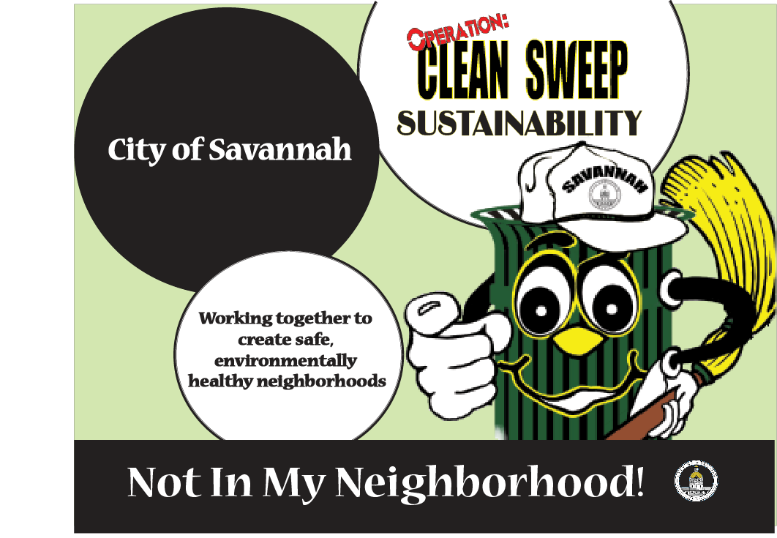

Operation Clean Sweep

One of the top six priorities of the Savannah City Council is to enhance the quality of life in all neighborhoods for all citizens by eliminating blight. City staff in seven bureaus strategized and formulated creative methods to reduce crime, eradicate blight and improve home safety and environmental conditions. In order to achieve this goal, the following initiative was launched.

On January 10, 2005, the City of Savannah implemented Operation Clean Sweep (OCS), a blight eradication program that combines the services of seven City Bureaus to improve the quality of life in neighborhoods. Through a collaborative effort of the City, neighborhood residents and businesses, Operation Clean Sweep endeavors to make our city a clean, safe and environmentally healthy place to live.

Operation Clean Sweep focuses on areas with a high concentration of blight and criminal activity. Staff identifies neighborhoods that meet this criterion and draw boundaries of sub-areas. These sub-areas designated as “hot spots,” represented the highest concentration of blight and crime in the neighborhoods.

The OCS team employs a six week process prior to entering a target area, which allows staff sufficient time to identify physical conditions, code violations, initiate enforcement action, and ensures that the City’s requirement of due process is met. This process also gives residents advance notice to resolve blighted issues that they are responsible for.

Participating Public Bureaus - The participating Bureaus provides the following services.

Savannah Fire and Emergency Services - Performs home fire safety checks, smoke detector inspections and installations, provides blood pressure checks, and identifies residents with special needs.

Water and Sewer - Checks for leaking fire hydrants, inspect water and sewer lines for blockages and leaks, and ensure safety of manhole covers and other water and sewer infrastructure.

Public Development Bureau - Public Development provides overall planning and coordination of the Operation Clean Sweep Program. Property Maintenance - Identifies and processes Property Maintenance code violations, to include derelict vehicles, unsafe buildings, overgrown lots, trash and debris, illegal parking, and graffiti.

Community Services - oversees public relations and citizen involvement efforts. These efforts include outreach programs to educate residents about Operation Clean Sweep and to encourage code compliance. Keep Savannah Beautiful comprised of private citizens in cooperation with the City of Savannah, also works with Operation Clean Sweep.
Weed and Seed - Provides the Police Command Vehicle which is the mobile headquarters for Operation Clean Sweep. The Command Vehicle houses information on Operation Clean Sweep, and has staff available from the Savannah Police Department to answer citizens’ questions and to handle their concerns about criminal activity in their neighborhoods. In addition, the Fire Department provides free blood pressure screening from the vehicle, and city staff is available to answer citizens’ questions about their property and other neighborhood issues. The Police and Fire Command Vehicle are on-site for 4 out of the five days that OCS is located within a targeted neighborhood.
Sanitation Bureau - Sanitation oversees bulk item pickup, litter and debris control, automobile tire pickup, the operation of the Bacon Park Transfer Station and documentation of improper containerization.
Facilities Maintenance Bureau - Facilities Maintenance oversees vegetation control along public rights-of-way and maintains lanes and City-owned lots.

Savannah-Chatham Metropolitan Police Department - The Savannah-Chatham Metropolitan Police Department’s Narcotics Eradication Team (NET) addresses moving violations, conducts warrant sweeps, counter narcotics operations, tows away unsafe vehicles that present an immediate threat and targets known ex-offenders living in OCS areas. The Savannah Impact Program (SIP) is a City program that consists of ex-offenders and probationers who assists with the cutting and cleaning of lots and the removal of bulk items.

Public Information Office - The Public Information Office prepares and distributes press releases and Public Service Announcements. It also books mascot Bennie “D” Bin for OCS week.

Organizational Structure
OCS has a coordinator dedicated to managing the initiative and the OCS services provided by the six bureaus and the General Administration Division.

Mayor and Aldermen
Assistant City Manager
(Public Development)
OCS Coordinator
City Manager
Zone Coordinators
Bureaus

Our 2005 Operation Clean Sweep results for 27 Neighborhoods include:
2582 home safety checks 692 hazardous trees removed
401.1 tons of trash removed 401.1 tons of trash removed
259 citations and arrests 1291 tires removed
337 water boxes services 1250 derelict vehicles removed
329 blocks of right-of-ways 1527 blood pressure checks
716 vacant lots cut 47 lanes cut/cleared

Given ample resources we will be able to face one of our major challenges – sustainability. To meet that challenge, the “Not in My Neighborhood!” initiative was established January 10, 2006, to provide implementation strategies for all citizen groups to participate by keeping their communities clean. Over the next 12-18 months, the “Not in My Neighborhood!” program will establish partnerships with businesses, neighborhood associations, churches, schools, and other civic organizations to take responsibility to help remove blight and crime from neighborhoods.

