2006 ICMA Professional Awards Nomination
Award for Career Development in Memory of L.P. Cookingham

Sanford B. Wanner
County Administrator, James City County, Virginia

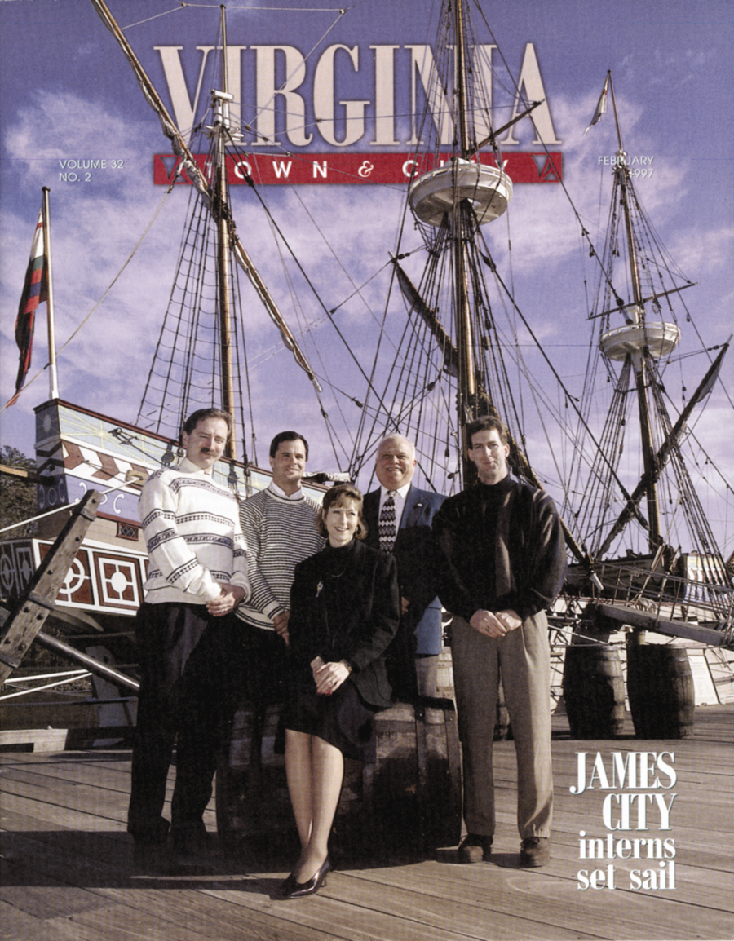
Perhaps it’s the proximity to Jamestown, site of the first permanent English settlement in 1607 and birthplace of representative government. Or maybe it’s because his almost fifty years of public service could be a case study in career development. Regardless, it is fitting to nominate Sanford “Sandy” B. Wanner, County Administrator, James City County, Virginia, for the L.P. Cookingham Award because he is truly a model, mentor and advocate for career development.
A Model
Following a distinguished career with the United States Marine Corps where he saw first-hand that developing others to their fullest capacity is, in fact, a matter of life and death, Sandy joined local public service and subsequently worked for two public school systems in Virginia before joining James City County in 1985. During his more than twenty years with James City County, Sandy continuously serves as a positive role model for others.
Sandy “walks the career development walk.” In 1990, he participated in a job rotation that resulted in becoming assistant county administrator. And, when he became acting county administrator in April 1996, Sandy jokingly said, “Now that the assistant country administrator position will be temporarily vacant, there will be plenty of developmental opportunities for staff.” It was a promise he kept.
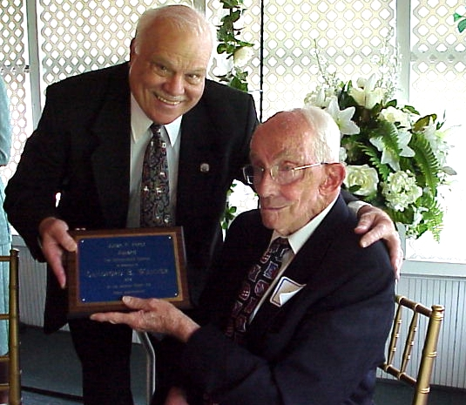
Continuing to learn and improve himself, Sandy obtained his ICMA–CM in 2003 and maintains certification by completing a minimum of 40 hours of learning and professional development each year. He completed numerous ICMA University classes and was a presenter at the 2004 Innovation Groups Transforming Local Government Conference. The topic? “Growing the Next Generation of Public Sector Leaders.”
In 2002, Sandy was presented the Hampton Roads Chapter of ASPA Julian F. Hirst Award for Distinguished Public Service. During 2003-04, Sandy served as Chair of the Virginia Local Government Managers Association (VLMGA) Professional Development Committee and planned and presented three professional conferences for his colleagues. He recently served on two ICMA Annual Conference Planning Committees.
A Mentor
Sandy serves as a mentor to many and encourages others to do the same. Under his tenure, district fire chiefs rotated among operations, prevention and training and the head of the police uniformed division swapped roles with the head of investigations. As a result, when the position of chief became available in both departments, the County had a pool of qualified applicants to fill the positions.
One of Sandy’s unique contributions is how he has cultivated the position of assistant county administrator as both an integral decision maker and an incubator for talent. As noted previously, when the assistant county administrator position was vacant, Sandy used the opportunity to identify “up and coming” staff members and have them work half-time on special projects outside of their primary duties. For example, a human resource coordinator worked with the local transportation district to install new signage and a landscape foreman facilitated meetings for the regional jail authority.
Sandy met with interns regularly to provide guidance, feedback and most importantly, encouragement. The “Intern Assistant to the County Administrator” was so successful it was featured in Virginia Town & City and received a 1997 NACO Achievement Award. Intern Mike Gentry said “The time spent with Sandy was an education better than any classroom.”
In 2003, Sandy instituted another noteworthy career development milestone -- six-month Succession Management Planning Assignments. Building on the belief people learn best through real-life experiences, the first round of assignments placed five employees in positions that would test and stretch their capabilities. Further demonstrating his commitment, Sandy earmarked the assistant county administrator position as one that was filled during the half-year long temporary assignments.
The County just completed its third round of Succession Management Planning Assignments and the results include a department manager who appreciates the complexity of competing requests for resources, an assistant department manager who competed successfully for the position of department manager, and a program manager who left the County for the position of department manager for a neighboring locality. While 4-6 employees participate in Succession Management Assignments each year, Sandy invests in the career development of 40-50 managers/program heads each month through his Management Team Forum, a development opportunity that provides activities and discussion that focus on strategic issues such as needs of our aging population.
An Advocate
Amy Baker, who has worked with hundreds of professional managers throughout the country, observed “Sandy stands out and sets a new standard for other local governments to emulate. “ Amy is the former Executive Director of the Virginia and North Carolina Innovation Group.
Sandy welcomes new employees at the New Employee Orientation Tour and encourages all to participate in the County’s tuition assistance and leadership development programs sponsored by the County, Chamber of Commerce, Colleges and Universities. Each year, he recommends an employee to serve as United Way executive-in-residence. His encouragement can be quite personal -- he is known for dropping into your office for a chat or leaving flyers on your desk with a note that says “Sounds like something for you.”
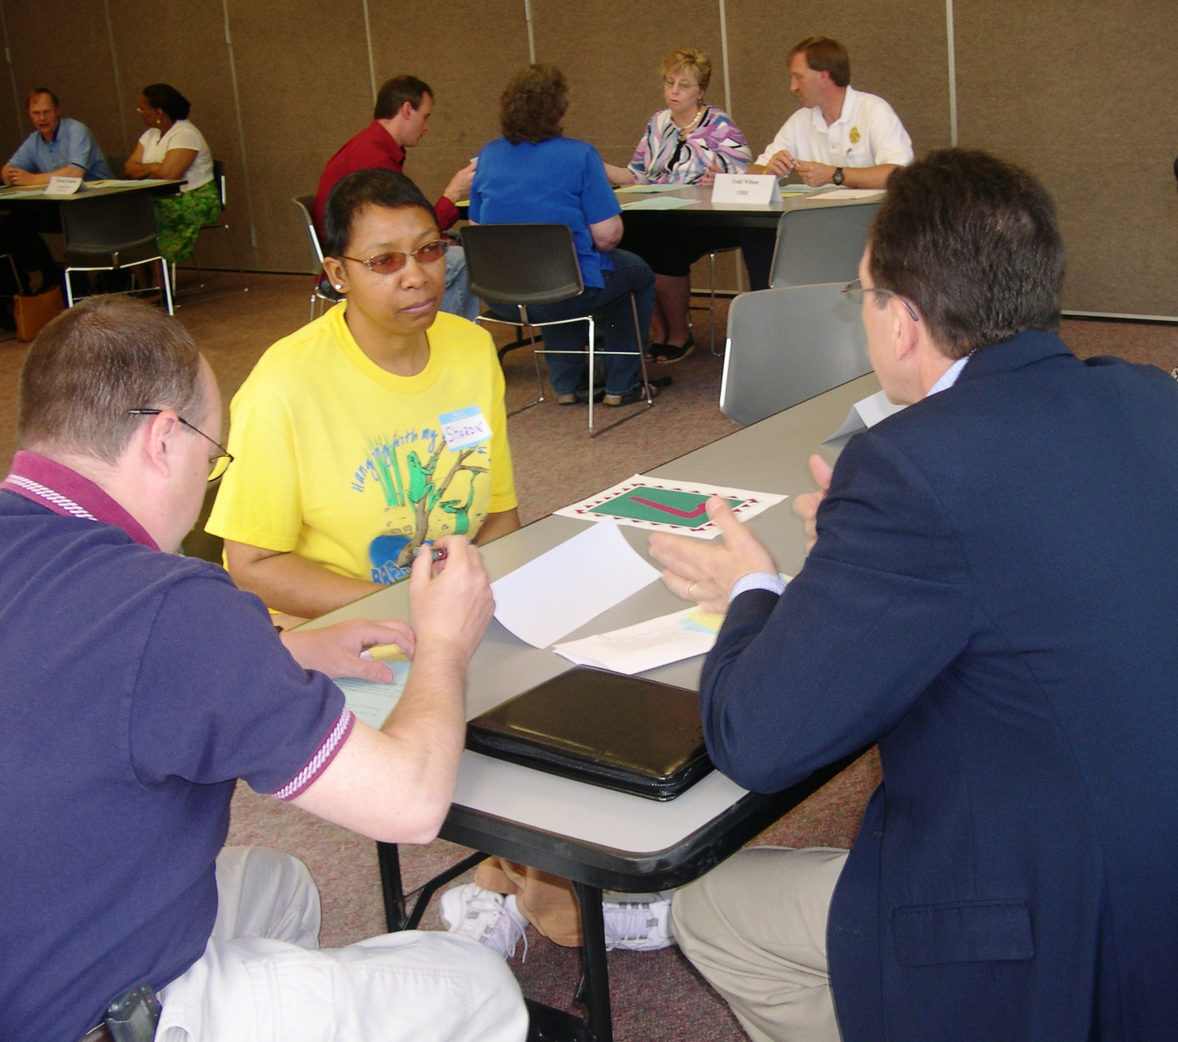
In response to employee interest in learning more about career options, he supported a range of initiatives including, “Promoting Yourself within the County,” a class that provides employees with peer feedback about their interviewing skills and “Shadow Program,” a short-term exposure to career opportunities within the County.
In addition to advocating career development for “paid” positions, Sandy demonstrates an unwavering commitment to developing the “unpaid” position of citizen. He extends his encouragement to citizens by supporting and speaking at the County’s Citizens Leadership Academy, New James City County Citizen orientation, Citizen’s Police Academy and Citizen’s Fire Academy.
In an article featured in the July/August 2003 issue of the Virginia Review, Wanner implored other government executives to take responsibility for developing others. Being a career development advocate is not always easy. Sandy always encourages employees to pursue better opportunities, even when it may result in losing a valued employee. When two employees in one year were accepted into the prestigious Presidential Management Intern Program, Sandy commented, “I take pride in the fact that James City County prepared them so well.” He also continues to support succession management planning assignments even after the local newspaper once denounced it as a smoke screen for dealing with controversial issues.
As Chief Administrative Officer, Sandy ensures career development opportunities are provided for all employees. Under his direction, employees develop an annual plan that outlines development needs and accomplishments. According to Carol Luckam, Human Resource Manager, “Sandy supports our employees and their development. We even changed our tuition assistance program to include advances so that money would not be an obstacle for employees who wanted to pursue their education. As a result, the number of employees attending classes increased.”
What’s In It for Him?
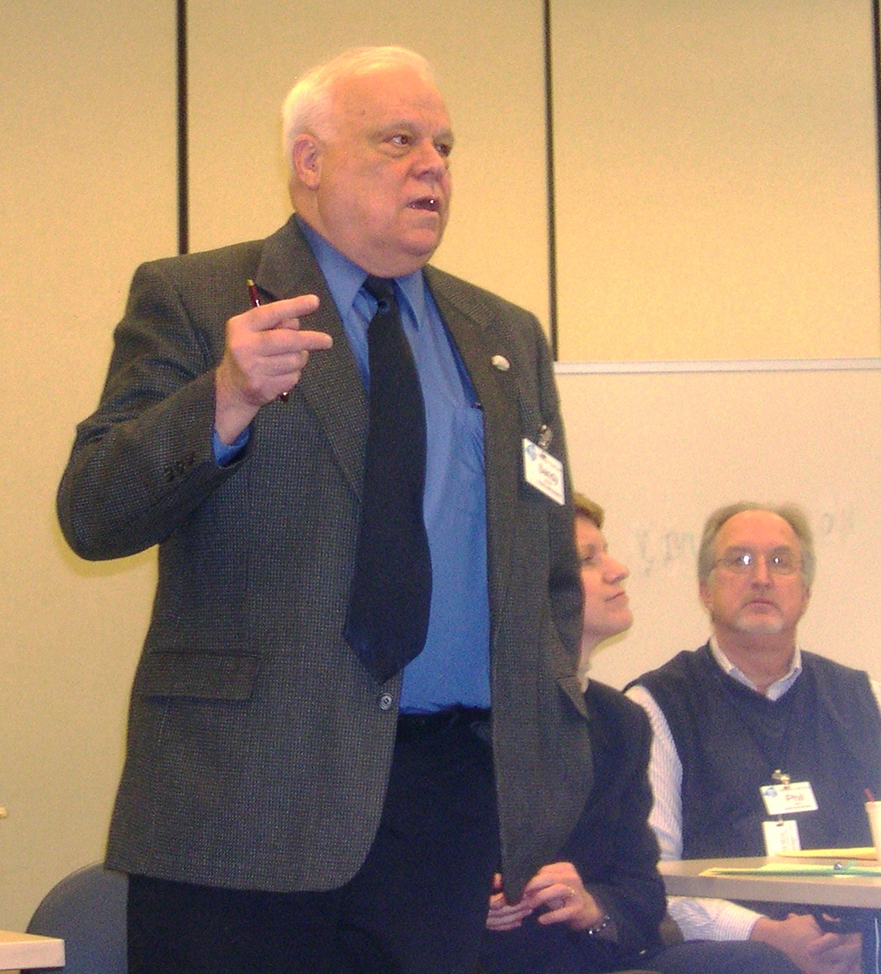
So why is career development such a high priority for Sandy? Simple. “I believe that today’s young employees are the future of the public service profession. Unless that talent and potential is developed and enhanced, we place our towns, cities and counties at risk. Career development today ensures tomorrow’s bright future.”

